# TypeScript 5 Deep Dive

Decorators – Decorators are a design pattern that have been in existence in JS and other programming languages for a while. They allow for a more elegant way to modify classes, accessors, properties, parameters, and also enhance functionality without changing the original code. Before to this Decorators feature in TS, developers used to use decorator pattern to add the run time behavior on the class like below. The logDecorator function is a higher order function as it take function as an argument or returns a function, or do both things –

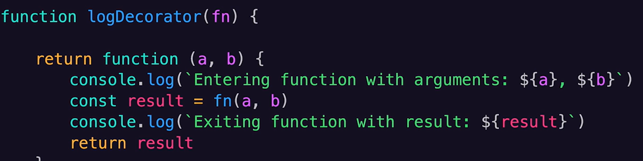

Below functionality is possible due to closure only, but in below pattern (prior to Decorator) every time we want to add extra functionality or flair to our add function, we might possibly have to either change the way our function is written or write some more wrapper functions. This is exactly why decorators were introduced –

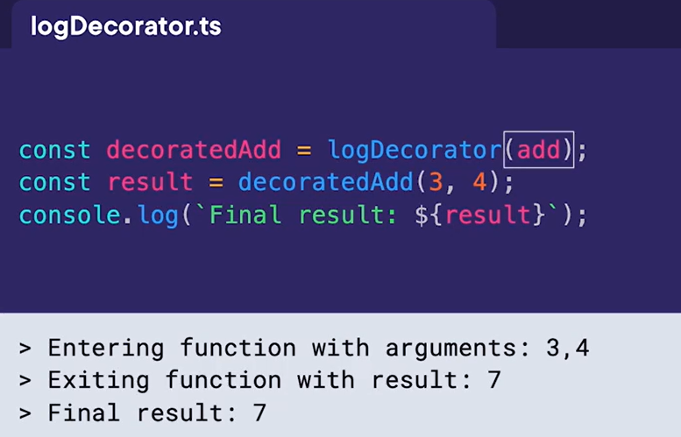

Closures are created when a function is created within another function. It allows the inner function to access the variables and parameters of the outer function, even the outer function has finished executing. This allows inner function to remember in quotes and continue to access the scope in which it was created –

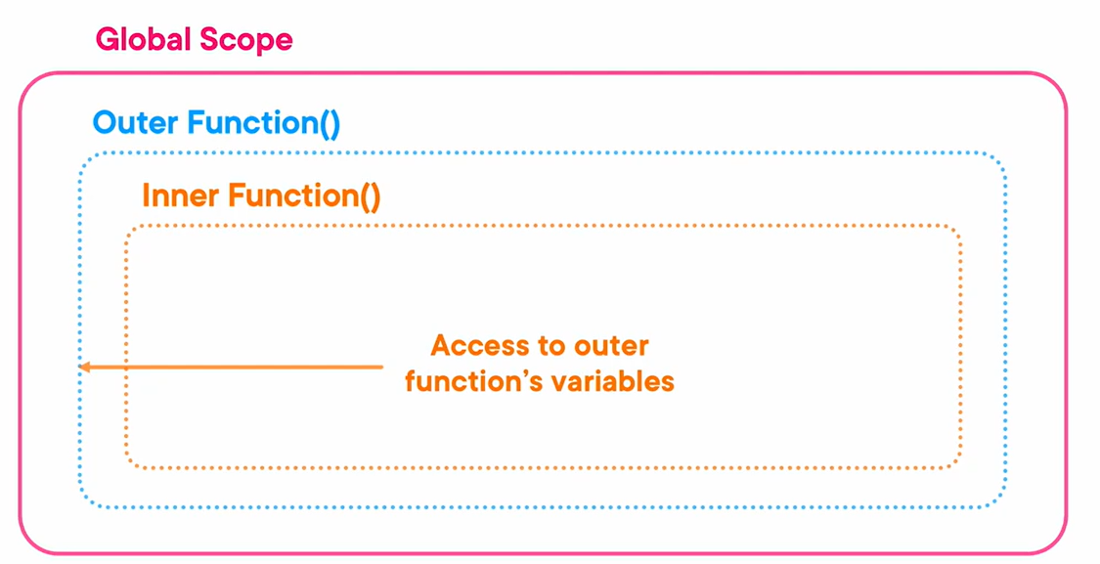

Now in TS, Decorators are fully supported, they are be applied to classes, classes fields, classes methods, class accessors–

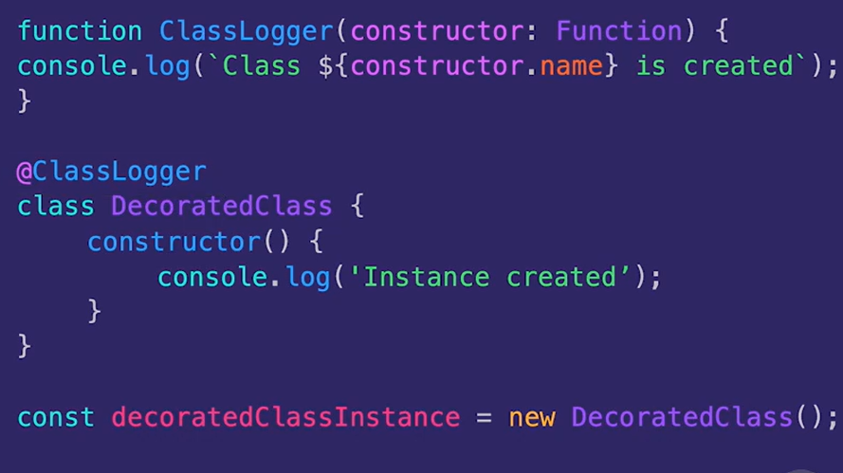

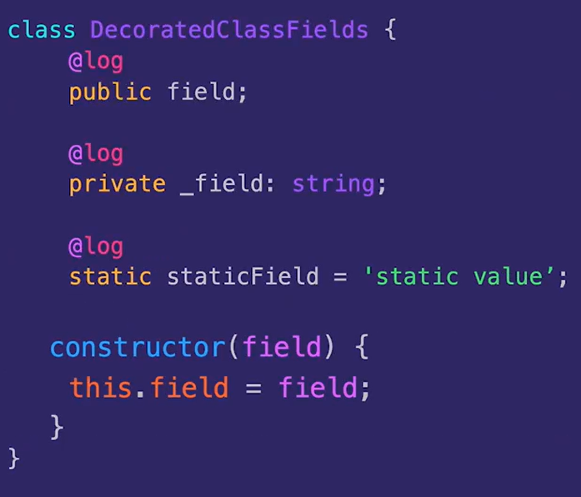

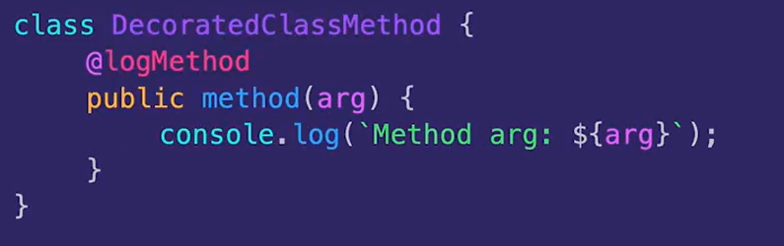

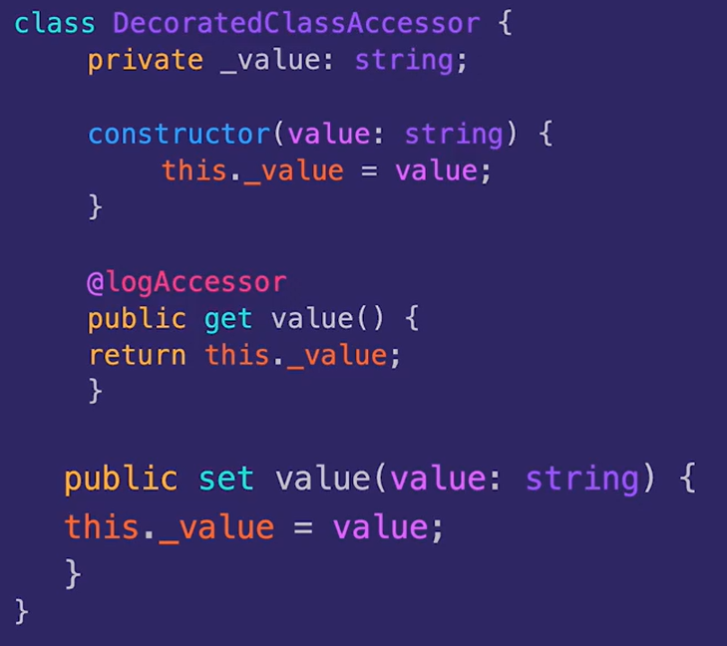

We should use noImplicitReturns flag to true –

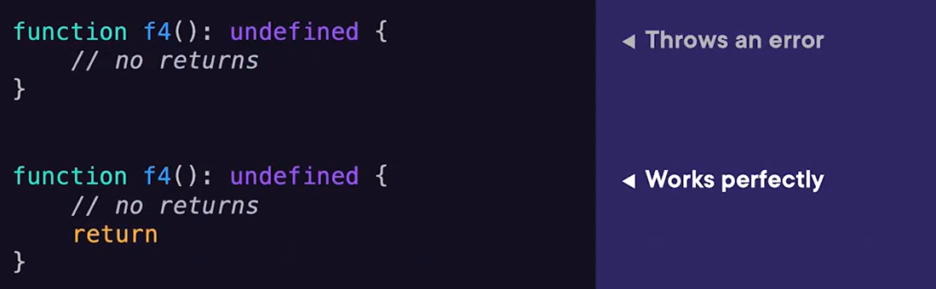

Import attributes are extra pieces of information you can attach to an import statement. In TS 5 if we are importing a JSON file then use below code which will consider it as a module especially with runtimes such as Node.js. The “type” is a import attribute, it provides more granular control and improved clarity for module imports –



Before and after Import assertions – this is particularly useful for non-JS assets and modules that require special handling. Without asserts importing JSON files directly using ESM would typically results in an error unless specific configurations or flags are used.

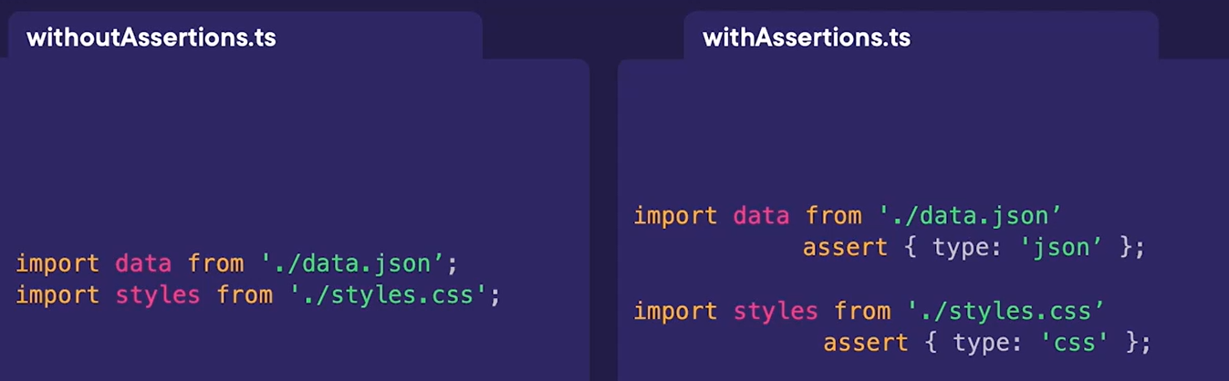

Object.groupBy –

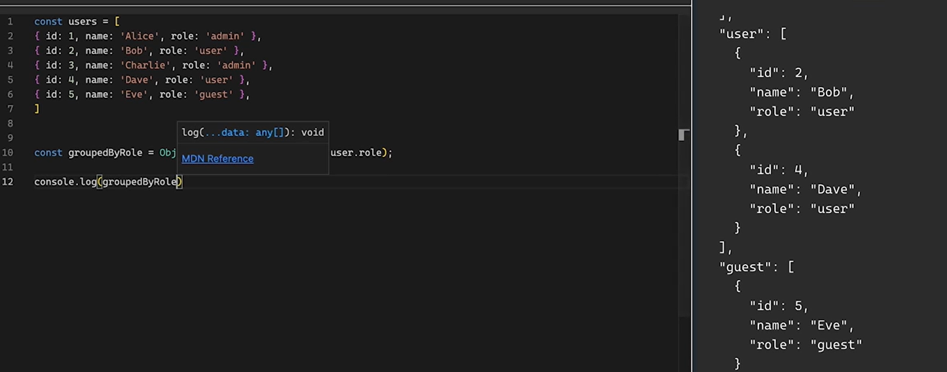

Note below quiz –

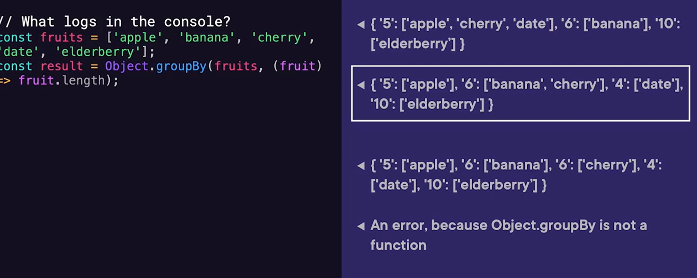

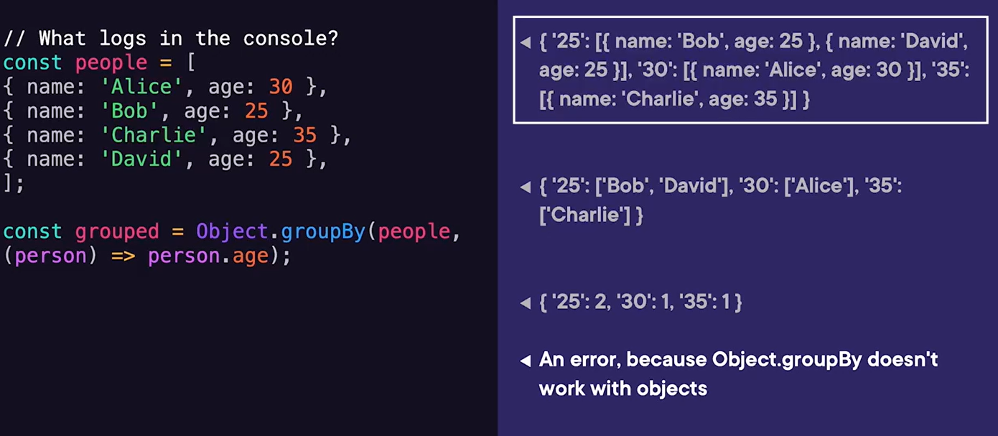

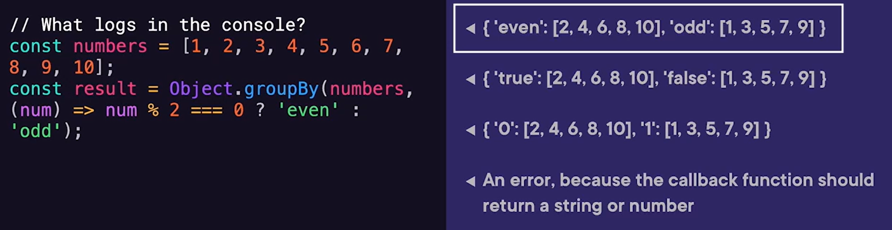

Map.groupBy – designed especially for maps() key-value pairs –

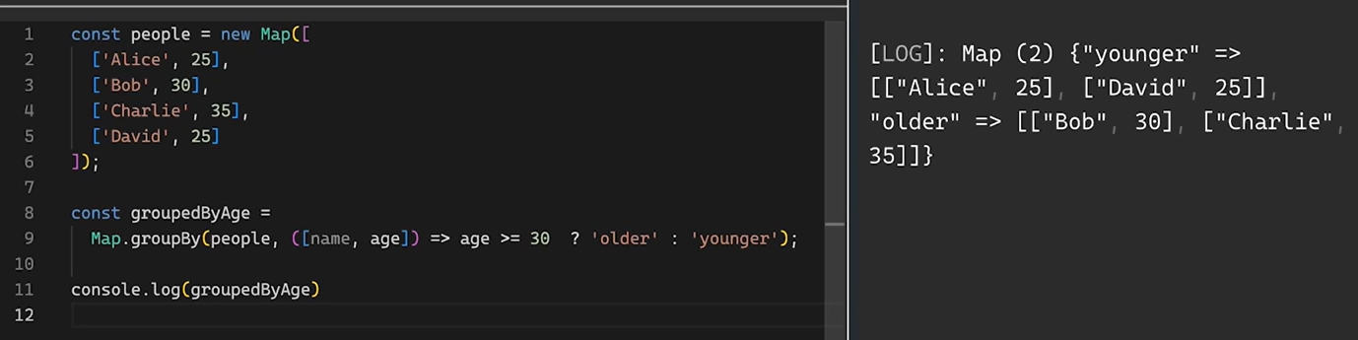

Const Type Parameters – it is a way to tell typescript infer the most specific literal type possible when working with generics especially useful when dealing with like tuple types or read-only arrays. They are very useful while working with scenario like configuration objects, passing data structure or preserving literal types with generics mainly used while building libraries or working with complex type-driven design, in day-to-day coding task we might not need that much of precision.

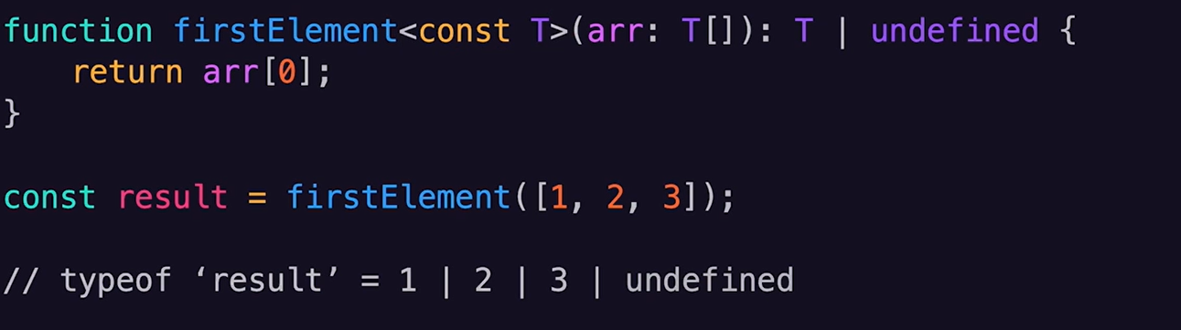

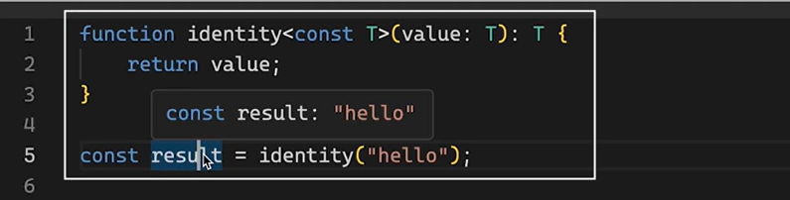

“Using” declarations – standardized way to manage resources that require cleanup after use like file handles, database connections or network sockets. The aim of the explicit resource management proposal is to simplify and automate the cleanup of resources by ensuring they are properly disposed of when no longer needed, reducing memory leaks and resource misuse. It should implement Disposable interface –

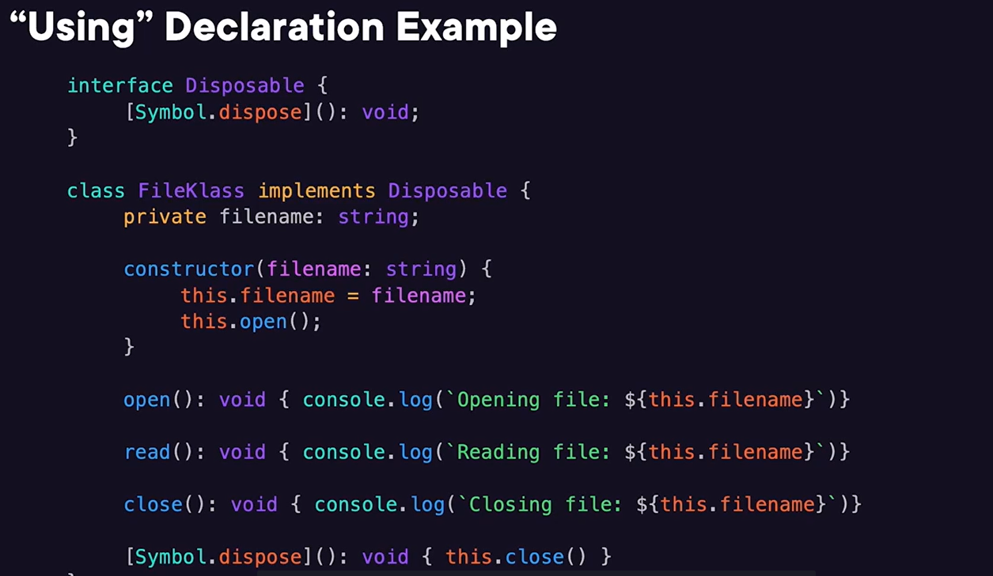

When the scope of the “using” keyword gets over, it resource will automatically cleaned up.

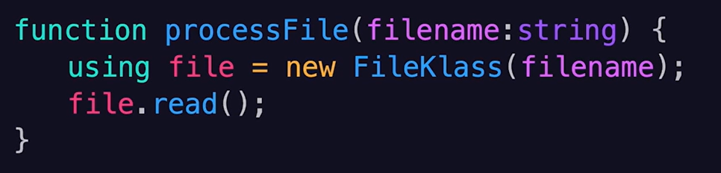

Multiple configuration files in “Extends” – earlier when you wanted to extend your TS configuration, you could only specify a single file in the extends field. But now, we have a flexibility to list multiple configuration files. Use cases – separate configurations, reusable configurations, overriding settings.

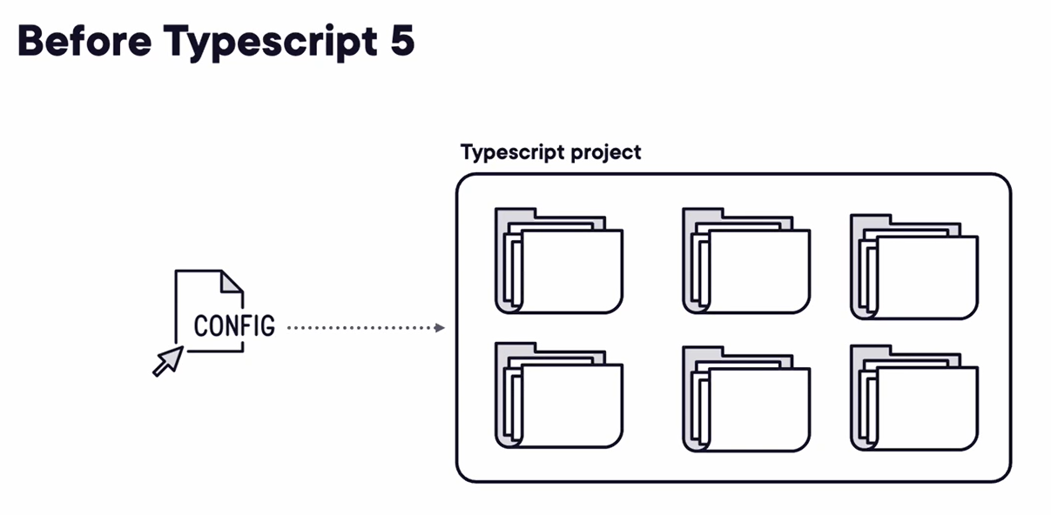

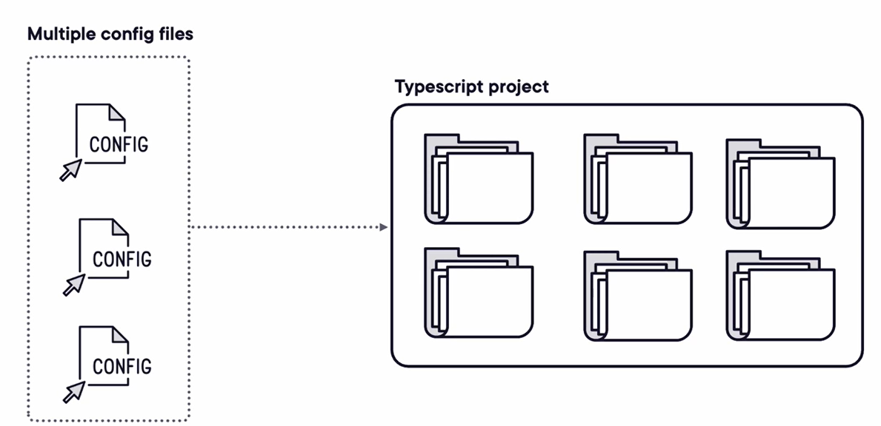



Literal types – they represent specific, exact values rather than a range of values, allowing for more precise type checking and constraints. Like string, number, boolean. They can become powerful when combined with Uninons.

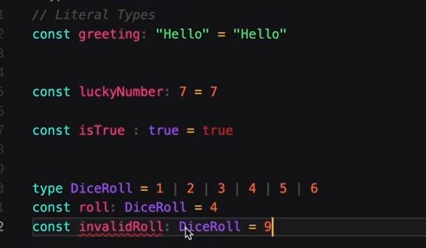

It can be used in function for more specific parameters –

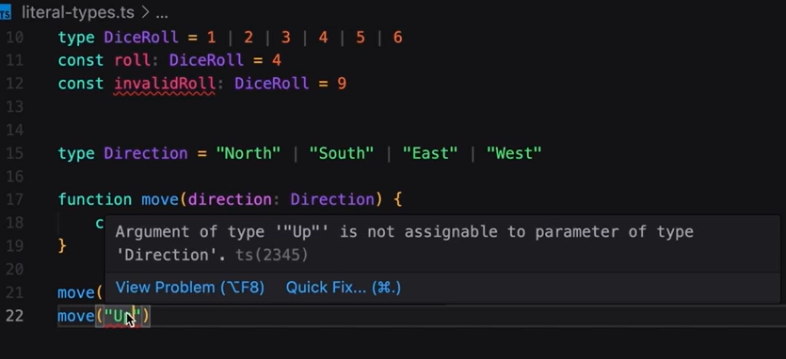

Union types – it enable a variable, parameter, or return value to accept multiple specified types. Useful in scenario where value can be of multiple types –

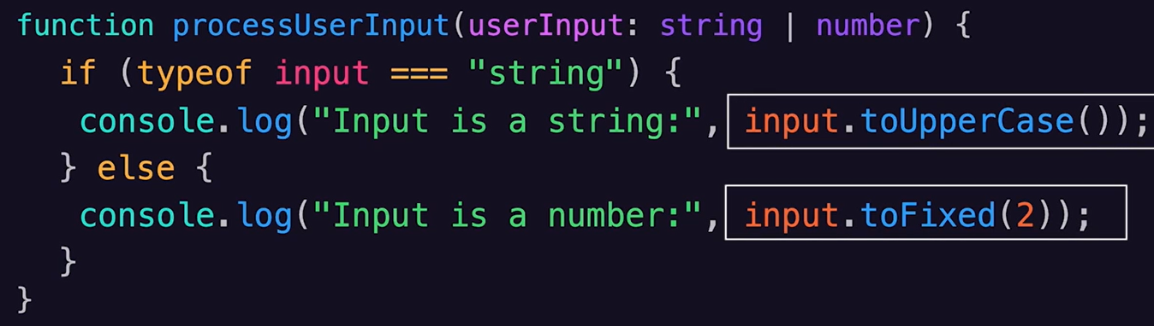

Discriminated unions – unions with interfaces – it is a pattern where a type can on of several variants, each identified by a unique “discriminant” property, enabling type-safe operations based on that identifier. It is also useful in making the property optional or explicitly marking that property can be null or undefined -

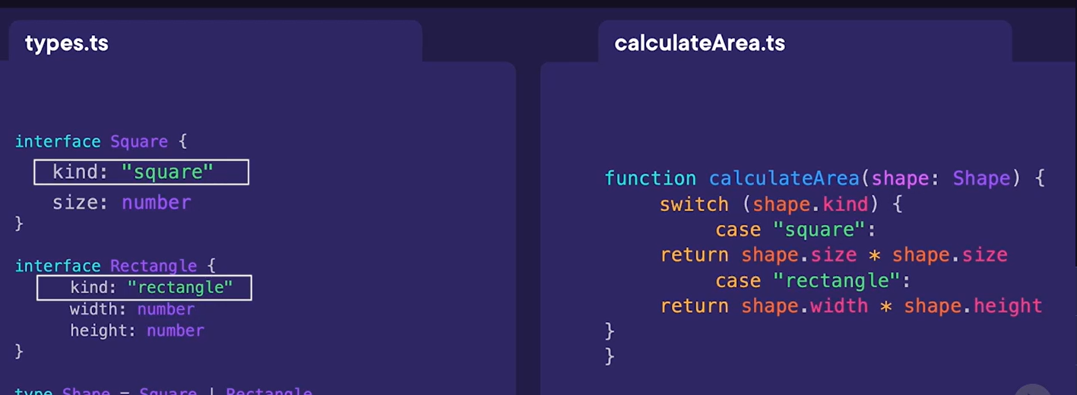

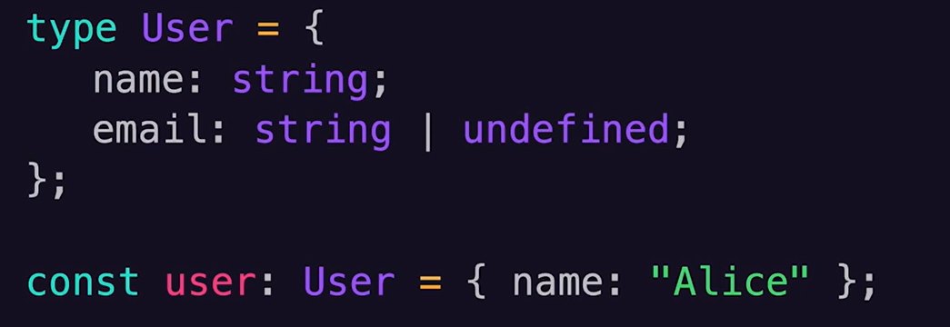

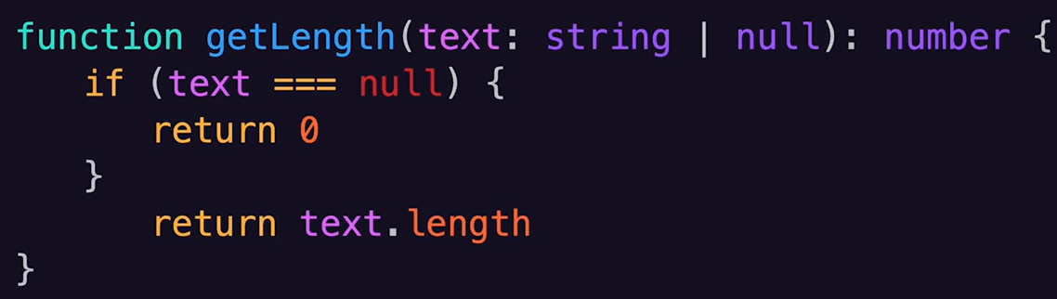

Intersection types – useful when we want to combine multiple types into one.

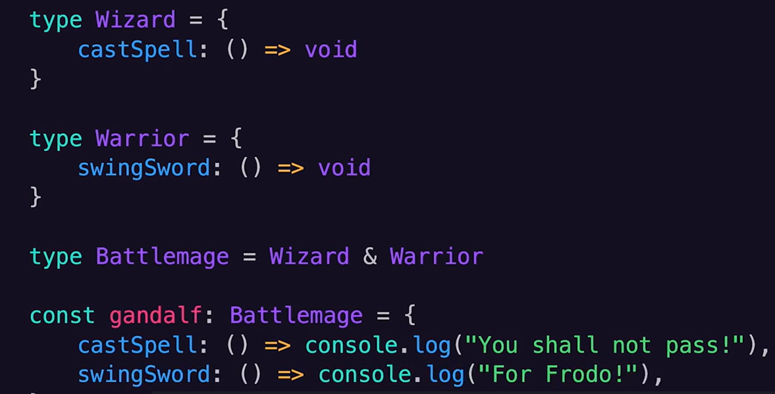

Note below – if it found two property with same number but with different type –

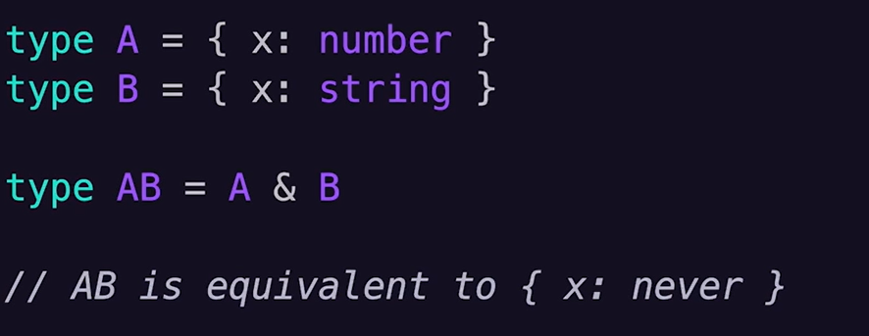

We can also have interactions on the functions –

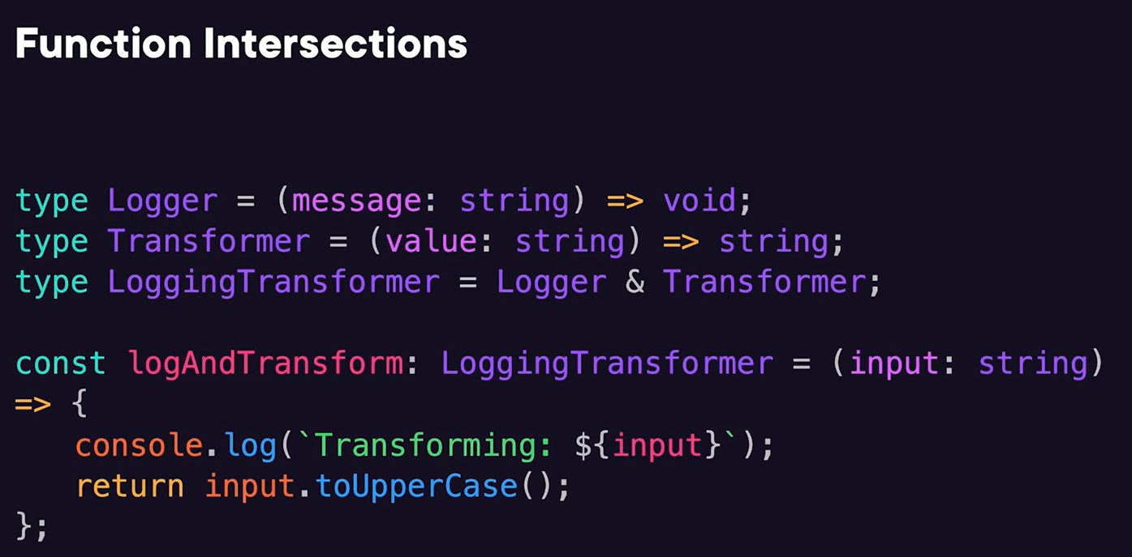

Type inferences – TS ability to automatically deduce the type of a variable based on its value or how it’s used.

Type assertions – they don’t change the actual type of the value at runtime, they’re purely a compile-time construct. It is useful in situation where we have information about the type of a value that TS can’t know about. Uses cases – while working with DOM elements or working with data from external sources.

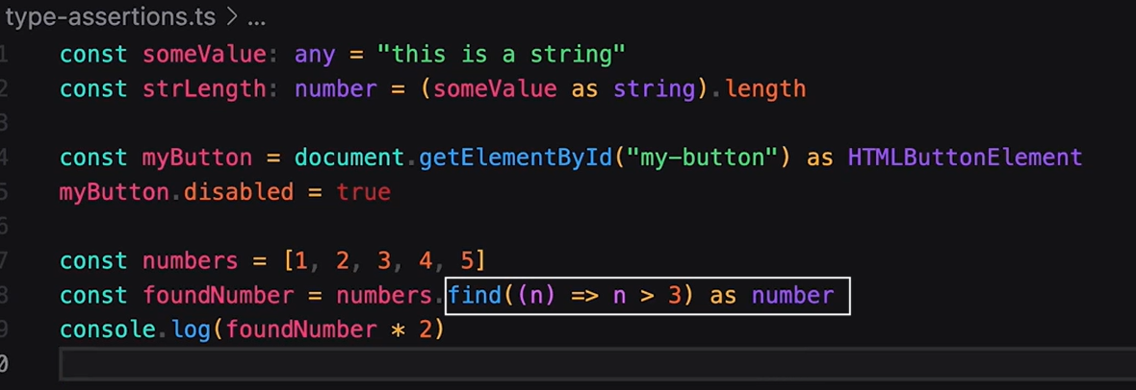

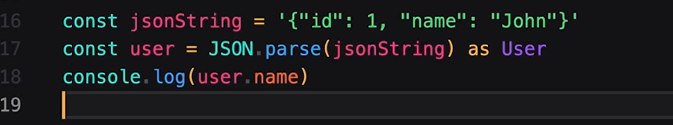

Custom type guards – it allows us to perform precise runtime checks and inform the TS compiler about the specific type of value. They are useful when dealing with union types or complex object structures where the exact type isn’t immediately apparent to the compiler.

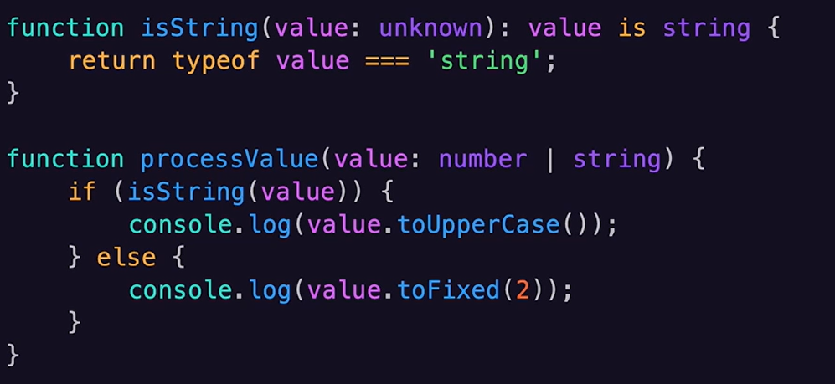

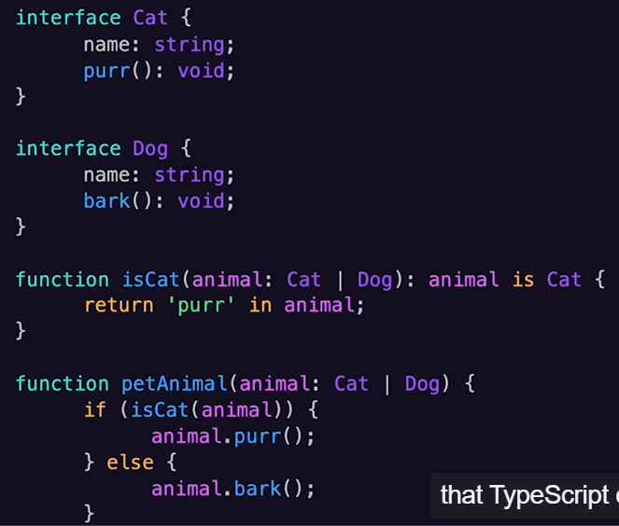

It also helps in implementing the exhaustive check scenario like below –

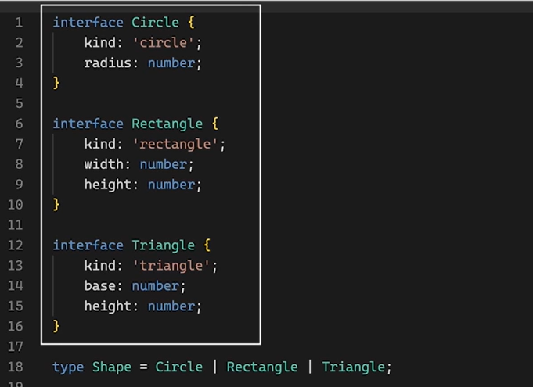

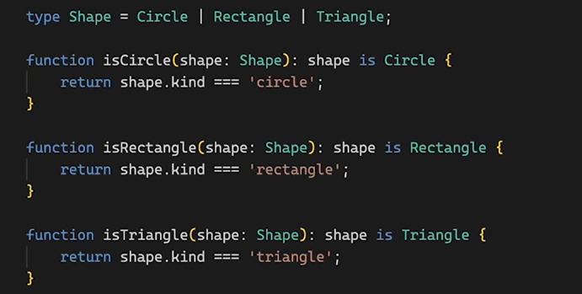

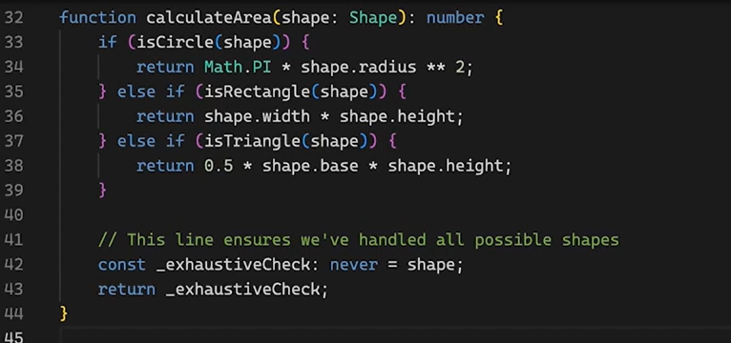

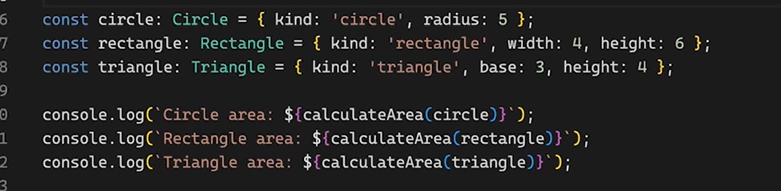

Function types – can also include optional and default parameters. We can also use type aliases –

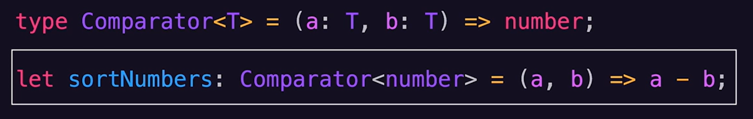

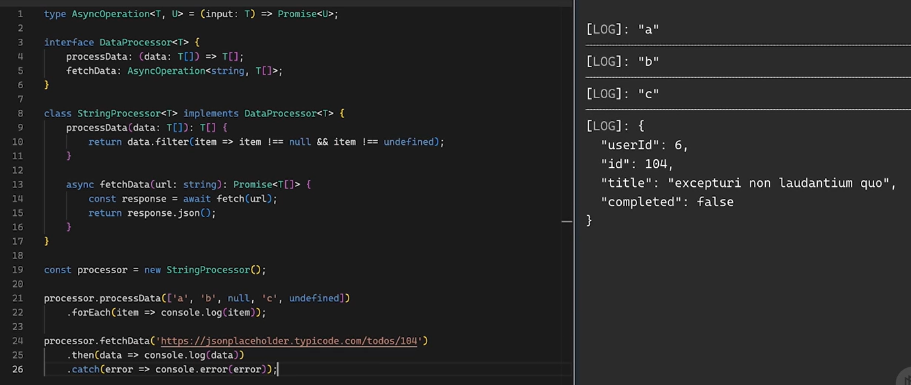

Classes access modifiers – public, private, protected.

Interface with dynamic key properties –

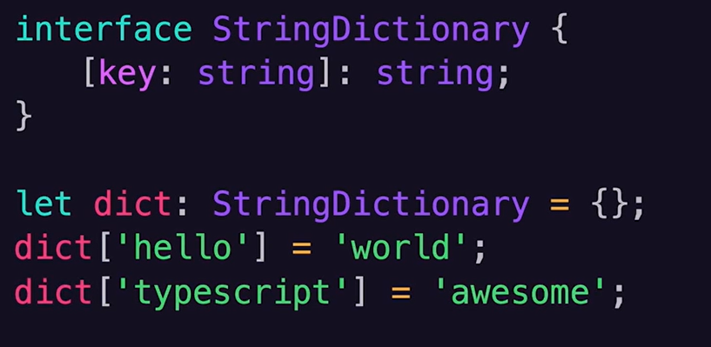

Interface with recursive types -

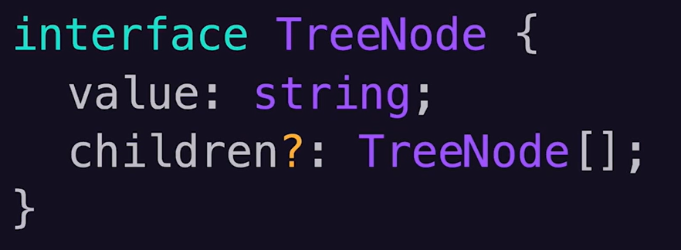

Imports and exports – to avoid global naming collusion first IIFE comes to picture, then for backend Node.js the CommonJS (require) has been introduced then for browsers AMD (defined) has been introduced. To bridge the gap between these different system UMD has been created, finally with the release of ES6, JS got its own native module system with import and export keywords.

Hosts in module system – each host like node.js, browser or webpack has its own way to resolve the module, so TS try to mimic those approaches during the compile time of the code. TS will try to imitate this resolution process during compilation time, it tries to figure out what the host will do at runtime so it can type check our code accurately.

Module resolution process –

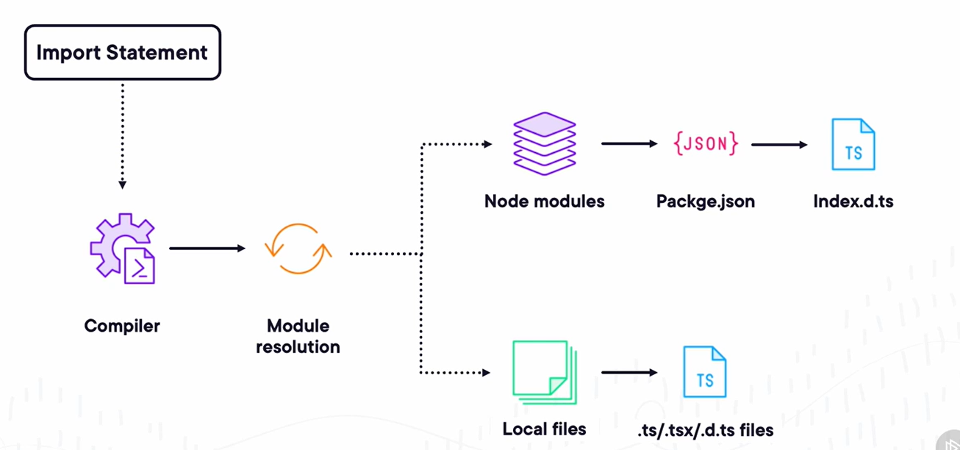

Namespaces (internal modules) – it is an older way when JS didn’t have the native modules. Namespaces provide a way to group related code (functions, classes, interfaces) under a single name to avoid global namespace pollution and to structure our code more logically.

Generics – it enable the creation of components that can operate with variety of data types instead of singular type. This approach not only prevents code duplicate, but also promotes more abstract, reusable code, all while ensuring type safety.

Decorators for metadata and annotations – they make our code more expressive and more maintainable. It is more like a little notes we can attach to our code, these notes are for TS compiler and runtime. Annotations are just a fancy way of saying we are using decorators to add these notes. Decorators in the real world – angular, type ORM, Nest JS. In simple terms, metadata and annotations allo us to write declarative code. Instead of imperatively telling the computer every single step we need to take, we can declare our intentions and let our framework or library figure out the details.

Metadata is the data that provides information about other data. Like food nutrition facts, it doesn’t change the food but it gives you important information about it. Ini TS we can use decorators to attach this kind of extra information to our classes, methods and properties. To use this feature, we need to set the experimentalDecorators and emitDecoratorMetadata settings in the tsconfig.json file. Also, to fetch the metadata we need to use the “reflect-metadata” library.

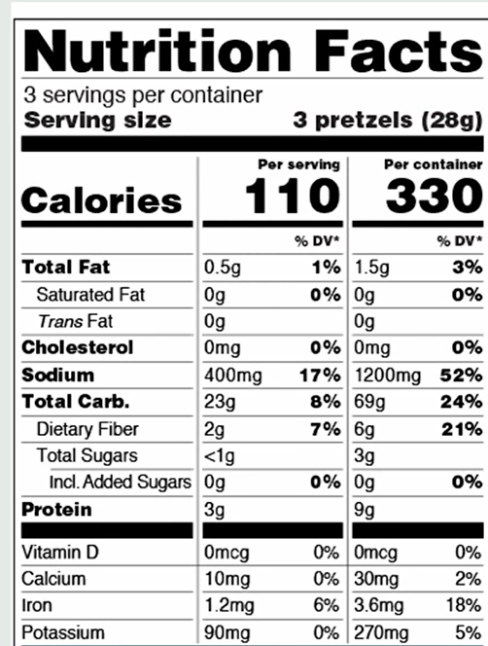

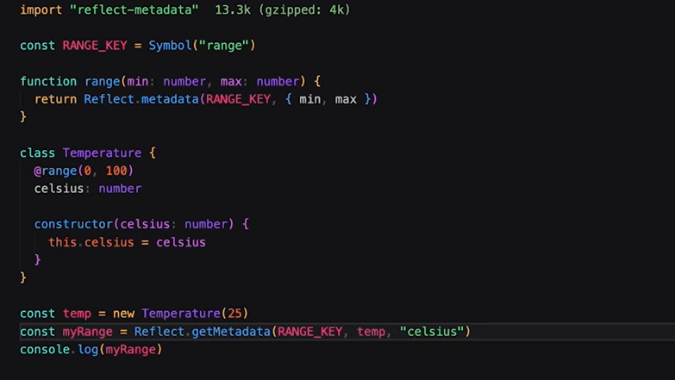

Using annotations –

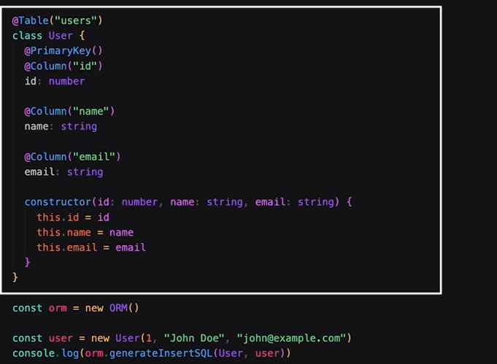

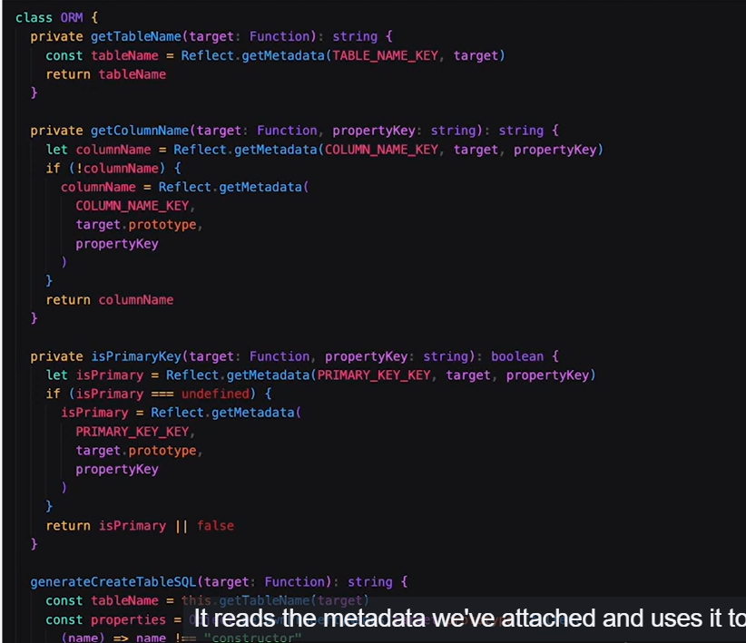

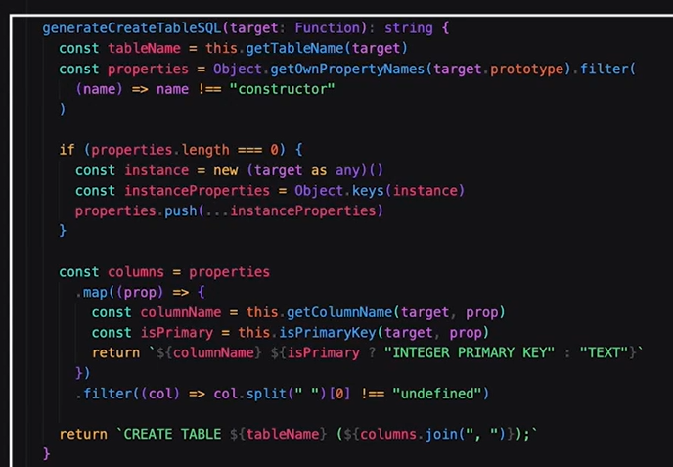

Mixins – it proves the way we structure and reuse our code. It define a set of feature or behavior’s that can “mixed in” to different classes. It is like creating a toolkit of reusable functionalities that you can apply wherever you need them. As TS typescript doesn’t support multiple inheritance directly, Mixins allow us to compose classes from multiple smaller focused pieces of functionality. They are useful when we have behaviors that we want to reuse across different classes, but which don’t fit naturally into our class hierarchy. They are unlike to interface as interfaces define a contract that the class must adhere to. Mixins actually provides a implementation, it is like the difference between a blueprint and a prebuilt module. In TS mixins are used by using couple of interfaces and functions that return classes. Benefits – encourages code reusability, provides architectural flexibility, complex problems are made simpler, an add new functionality to existing code.

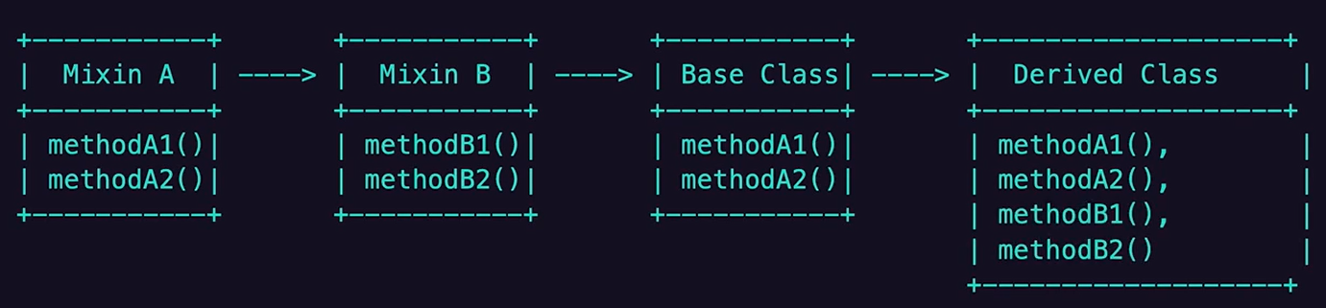

Simple example -

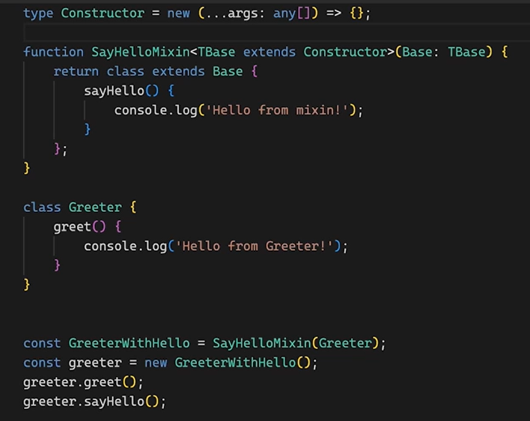

Complex example –

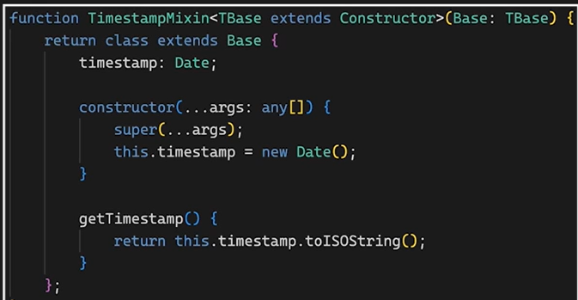

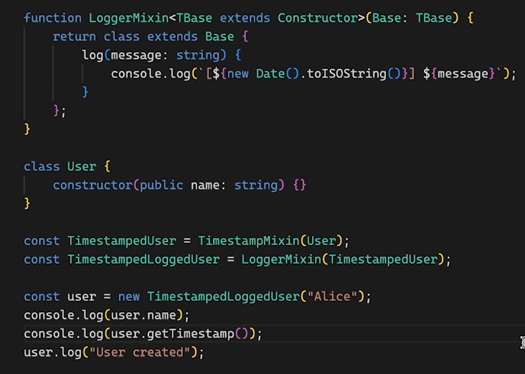

Mixins add the methods or properties dynamically on the class, so we need to use declaration merging in above code as below –

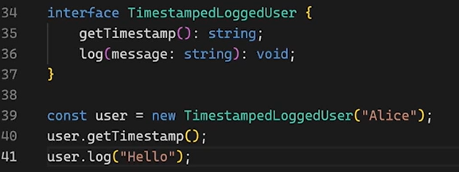

# Building TypeScript 5 Unit Tests with Jest

Preventing regression is the primary goal when testing a web application.

Essential Jest Keywords and commands – describe/suite, it/test, expect, before/after.

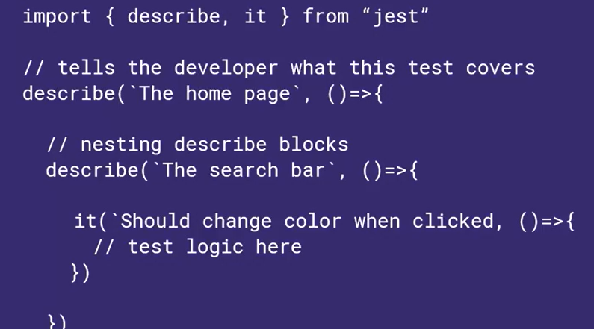

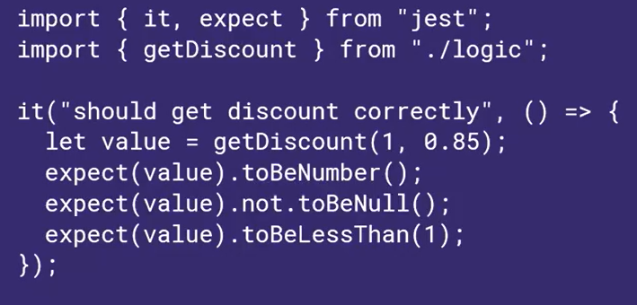

We should test application logic only like time zone converter, currency converter, data transformer, password validator, or file validator, not to test like external libraries, declarative (package.json), etc.

When to use mocks – aysnc effects, http calls, filesystem read/write, random effects.

While testing the web components, we should virtualize the DOM as browsers are very slow, consume lots of resources, are inconsistent. Testing libraries virtualize the DOM allowing streamlined testing. We can use snapshot testing which will automatically captures the html output of components and break if anything changes including styles. These tests are very fast and making them a preferred source of sanity when developing web components.

Snapshot file –

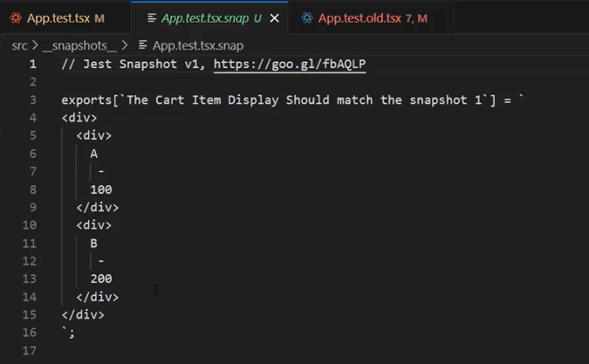

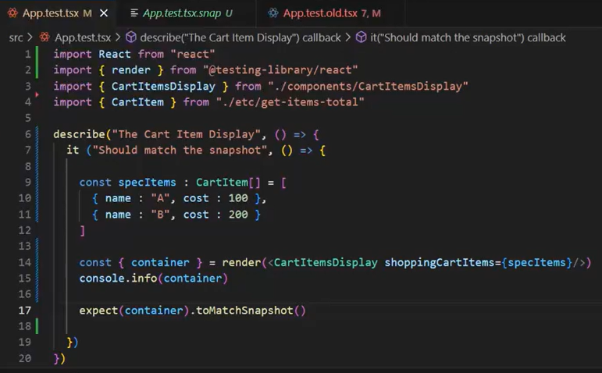

# TypeScript 5 Crash Course for JavaScript Developers

Both C# and TypeScript are designed by the same man, Anders Hejlsberg.

We use generics when we want tot benefits of typing, but we want to defer the decision about the typing to the other developer. Key-value pair is a primary use case of Generic.

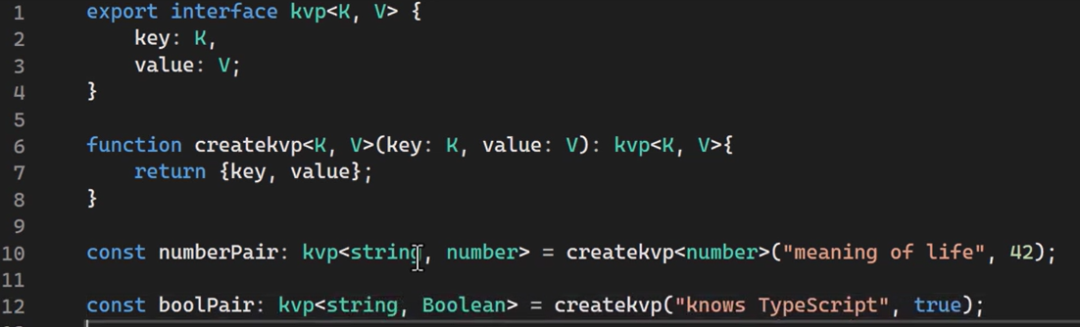

# TypeScript Best Practices

Structural best practices – we should follow LIFT principle – locatable, identifiable, flat and try to stay DRY.

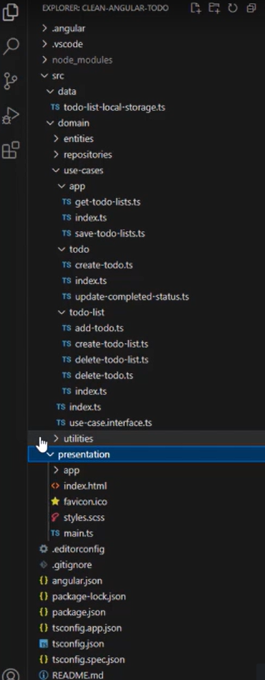

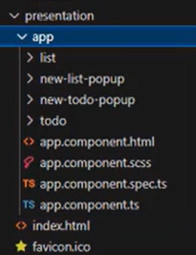

Architectural best practices – code in discreet modules is easier to reuse throughout the application, modules should adhere to single responsibility principle. We should favor a layered design by dividing the application into distinct layers each responsible for a different thing. Also, minimize dependencies between each layer. We should have Data, Domain and Presentation layers.

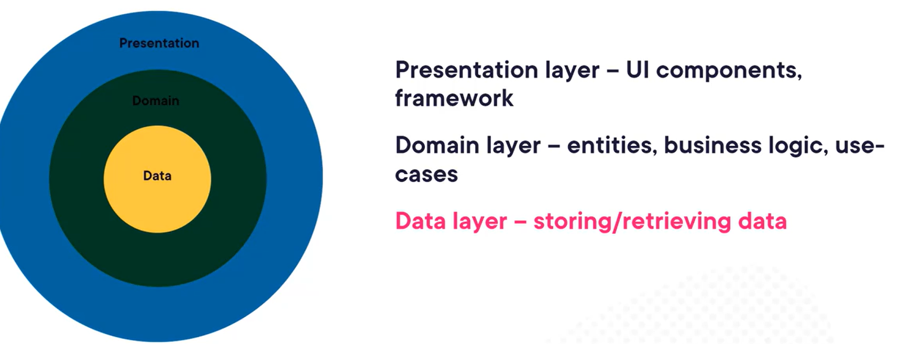

Dependency rule – dependencies should always point in, and should be one level deep. It is an exception for Repository -

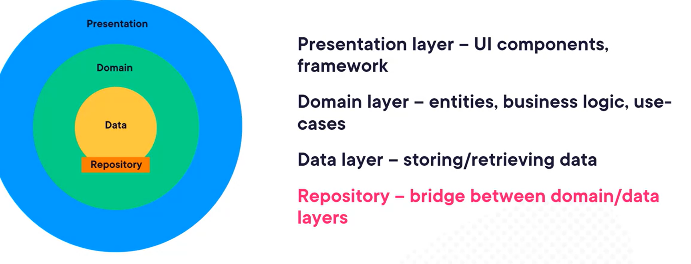

Repository – interact with a data source without knowing too much about that data source. It bridges between domain/data layers. 

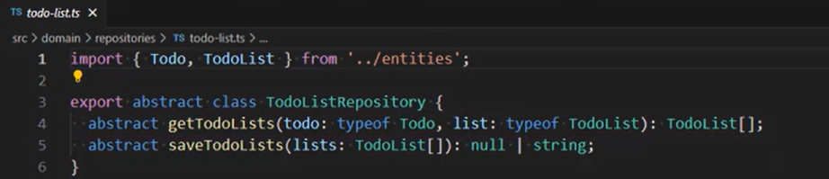

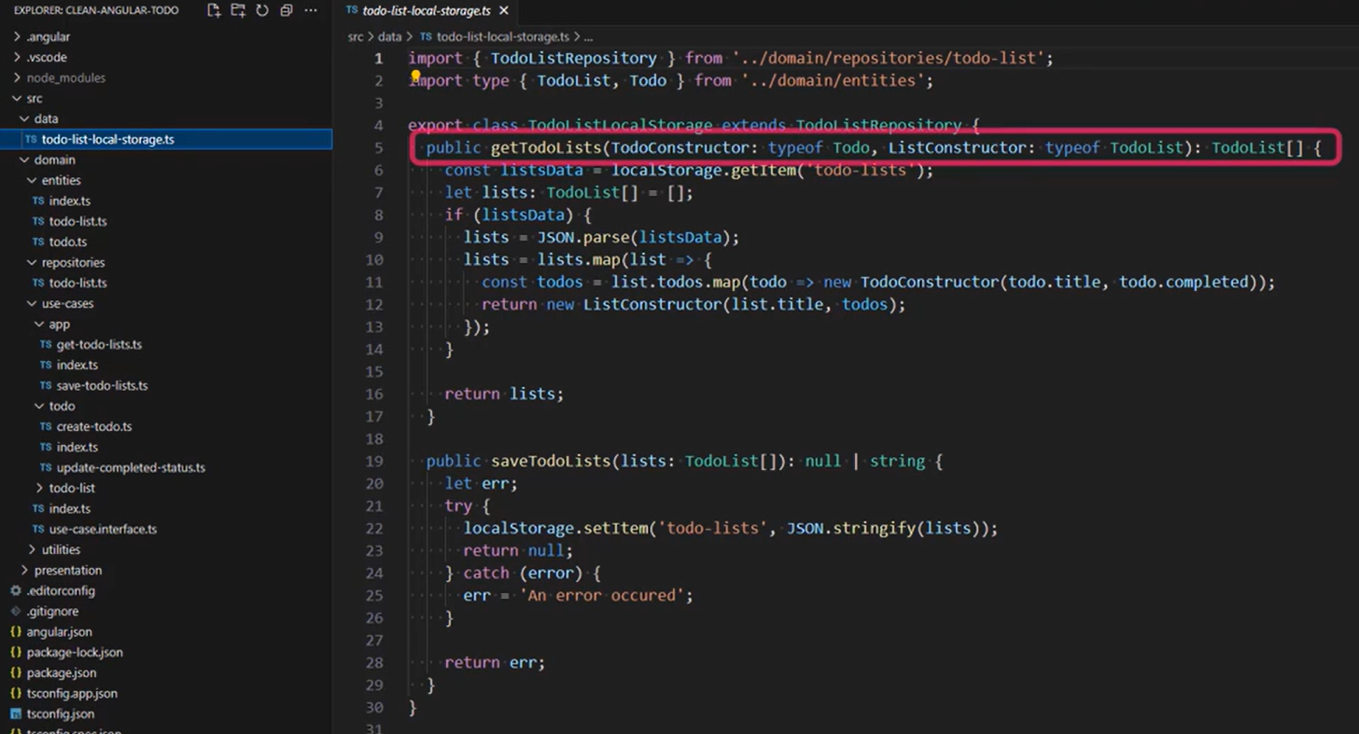

Configuration best practices – always enable strict mode, noImplicitOverride, noImplicitReturns, noPropertyAccessFromIndexSigntature, noUncheckedIndexedAccess, noFallThroughCasesInSwitch, noUnsuedLocals, noUnsuedParameters, exactOptionalPropertyTypes, noEmitOnError.

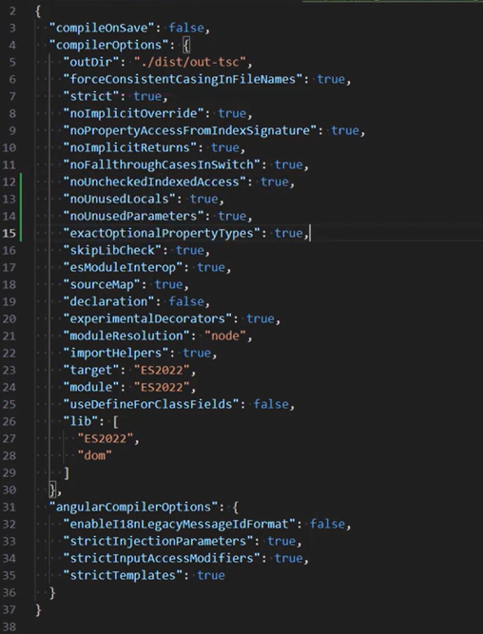

Strict mode strict sub-options –

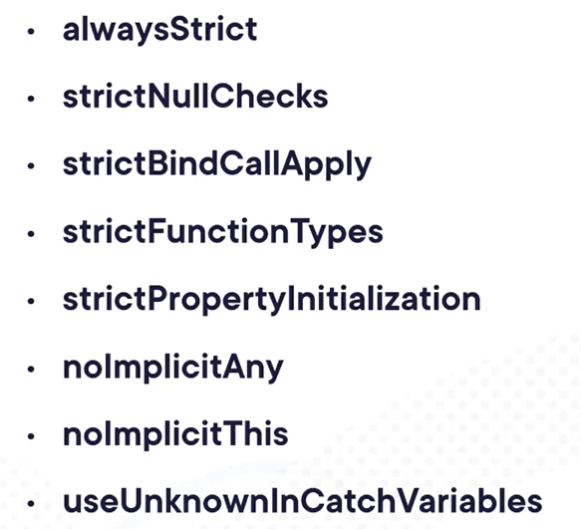

Tooling best practices – Git, VSCode, ESLint, Prettier, git hooks to automate tasks by using husky (pre-commit).

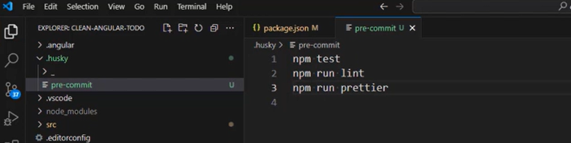

Language best practices – avoid ‘any’ type, handle null & undefined value safely. The null represents a value which is unambiguously absent.

If a value can contain null or undefined then we should explicitly mention it so that TS can suggest it to handle it accordingly, same with even while creating an object –

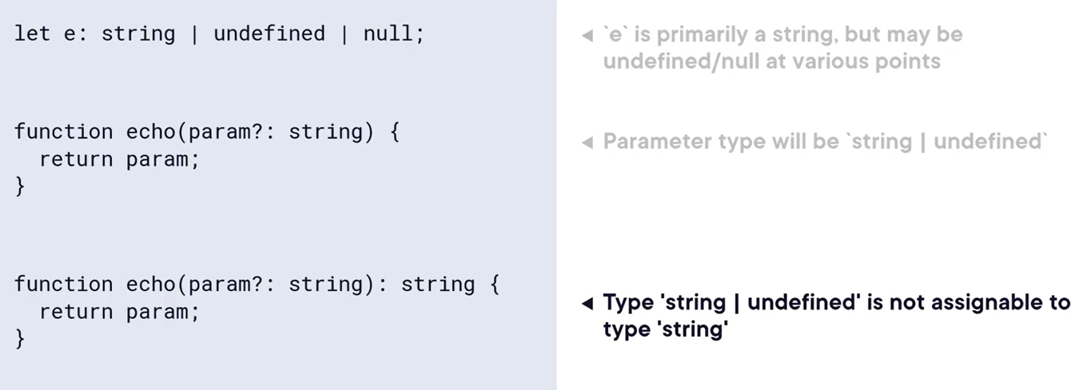

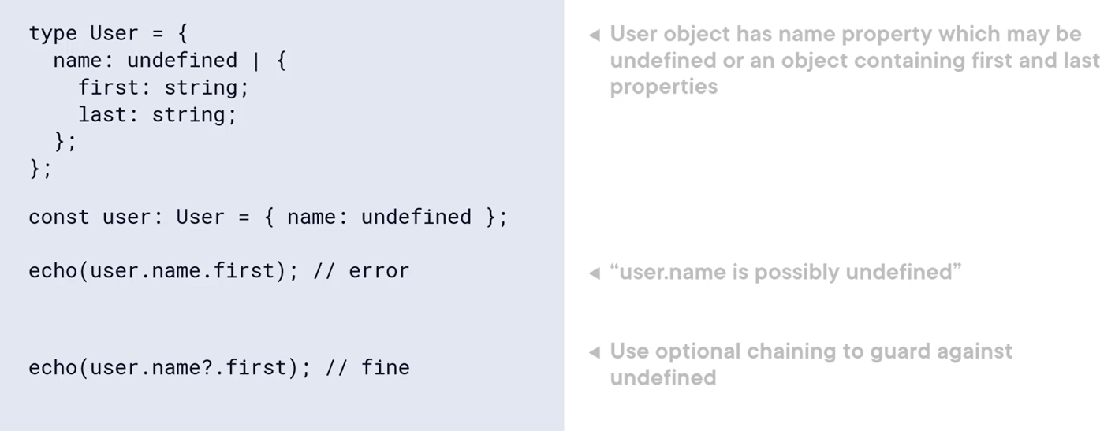

Avoid excessive annotation due to auto type inference. Every superfluous type is more code to type, read and maintain. So, we can avoid type annotations in below scenario –

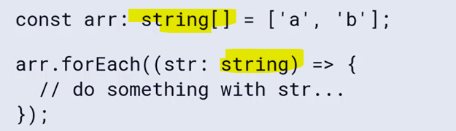

We should use Tuples for Fixed-length arrays, by using Tuple we can better express the array will have exactly two elements which makes self-documenting more readable –

We can also have named tuple which also provide type safety–

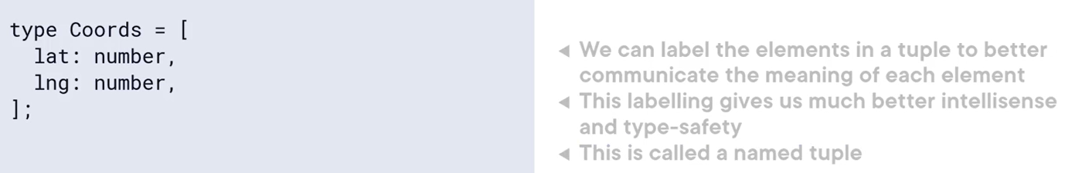

Use readOnly and readOnlyArray types – we should prefer const over let to avoid overwriting values by mistake. Also, the class properties should be readonly if they do not need to change after initialization.

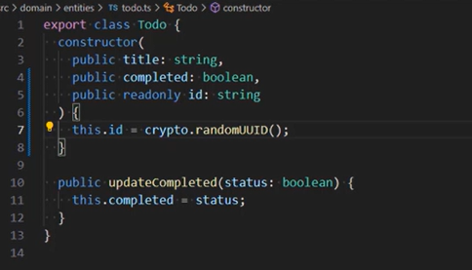

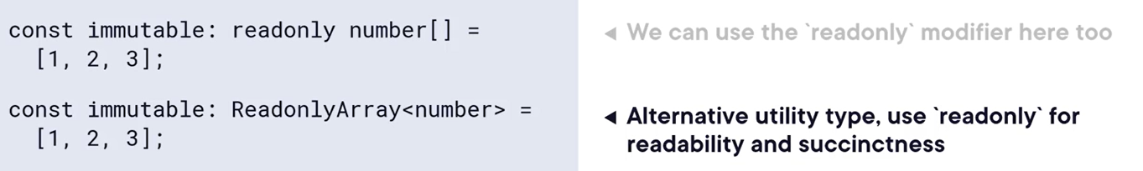

Use the Polymorphic ‘this’ (fluid API) – the ‘this’ object can refer to different things in different contexts, it is already polymorphic we don’t need to do anything special to make ‘this’ polymorphic.

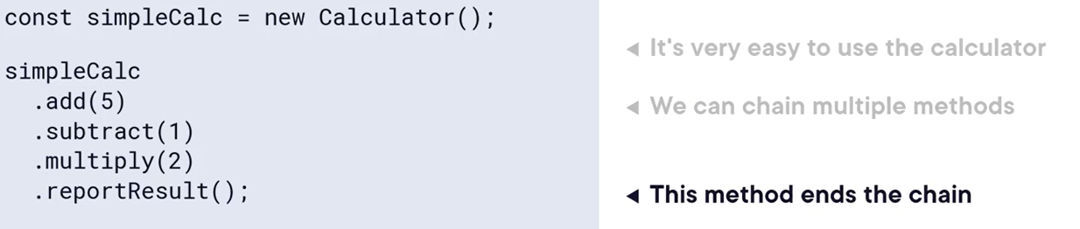

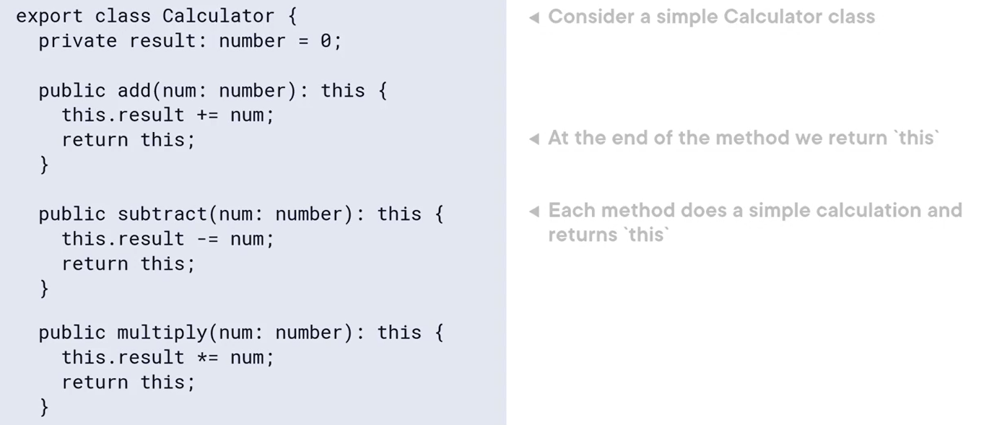

Favor type-guards over type assertions – instead of using a type assertion using “as” keyword to tell Typescript what type a value is, we should use a type-guard to test what type a value is. So, instead of below –

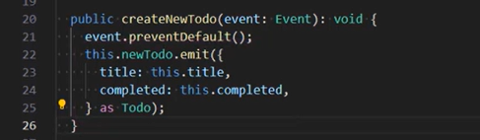

Use below -

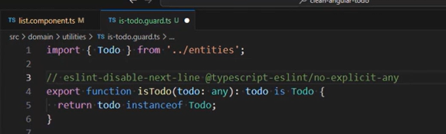

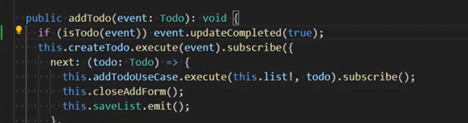

Make Switch statements exhaustive – we can achieve this by creating a utility method –

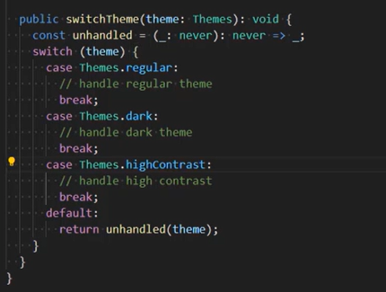

Use Utility types where applicable – like partial, required, record (describe and object-like structure containing keys and values).

Use Generics to make code more readable, maintainable.

Use conditional types – it represents a way to create a new type based on some conditional logic.

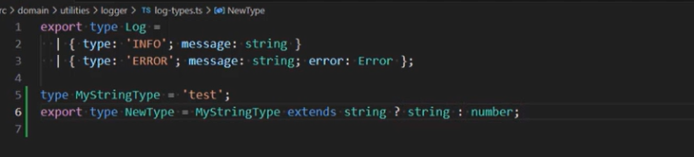

Use decorators wherever possible.

Asynchronous best practices – use async/await, always handle errors in async code, use promise.all (instead of having nested then() sequentially) & promise.race(). Use promise.all when you make multiple requests and can handle the results of all together.

Use loading states and timeouts – loading states serves as important visual feedback that “something” is happening like spinner. Types – determinate and indeterminate. If request doesn’t return data after timeout then we should replace loading state after a shot time with a message that the request failed. We can use primes.race() with a timout() value along with request.

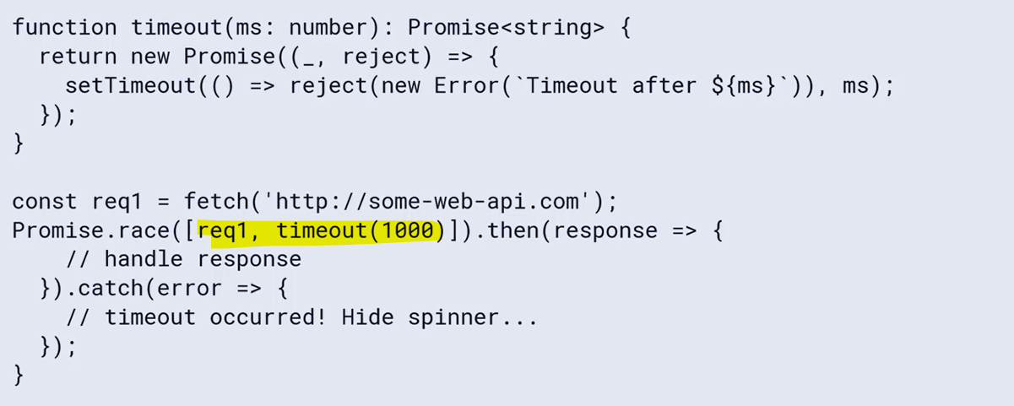

Always clean-up subscriptions otherwise it might impact the application performance.

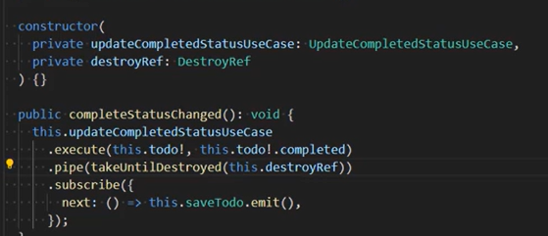

Error handling best practices – types – internal error, range error, reference error, syntax error, type error, URI error. Any errors not caught by us will bubble right up to the browser and potentially crash our application.

Never “swallow” errors, always do something with them. We should always take steps to mitigate the error, or report it back to the user. Also, never return a string instead of the error. Explicitly type the error as ‘unknown’ for readability then in the further blocks provide specific type –

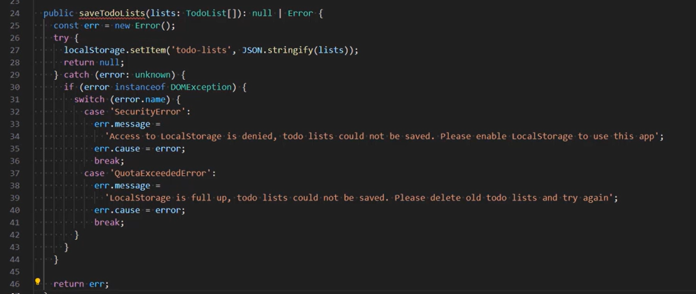

Throwing vs. Returning an error – we should throw an error when the error cannot be recovered from, return when it can. Also, as a best practice, use a union type including ‘Error’ when a function returns an error. Returning an error have advantages where it will be predictable control flow through the application, simplifies code by avoiding many instances of try/catch, avoids unhandled errors if we forget to catch them.

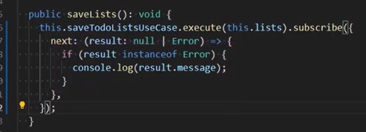

Throwing an error instead of returning it approach makes clear separation between error code and “normal” code, reduced checks for whether something returned by a function is an error or not, errors can be caught at any level, without manually propagating through multiple functions. Now, in function we need to use “never” as a return type instead of “Error” –

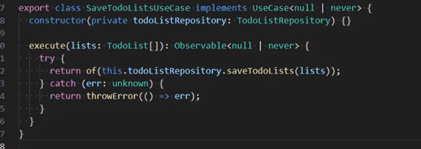

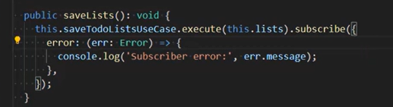

Use Error Classes – by using custom error classes – we can work with errors in a type-safe way, work with different errors in a consistent way.

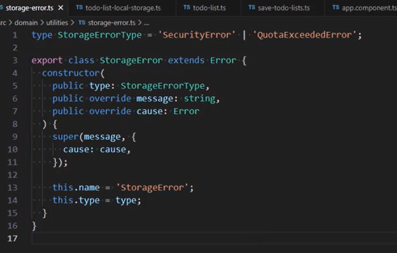

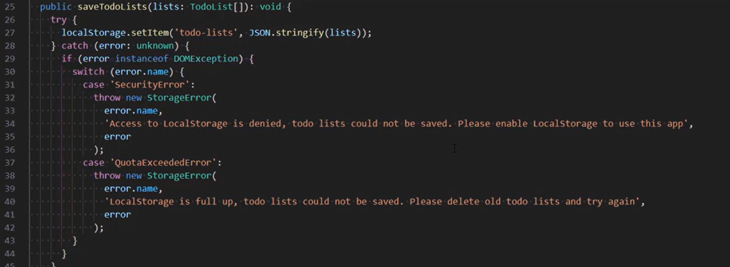

Provide useful errors and error documentation.

Performance best practices – implement lazy loading, use web-workers when tasks are intensive or heavy and can improve the application performance, break-up long running tasks by suing setTimeout() to break code into smaller chunks that can be run as individual tasks to prevent the main thread becoming unresponsive to user interactions, using throttling and debouncing to improve the web performance.

Think of throttling like slowing down a constant stream of events, without throttling, the resize event could fire many times, locking up the UI.

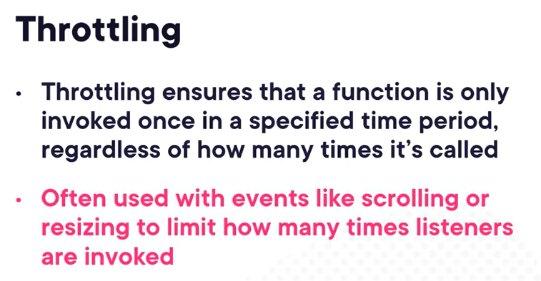

Core implementation of throttle function –

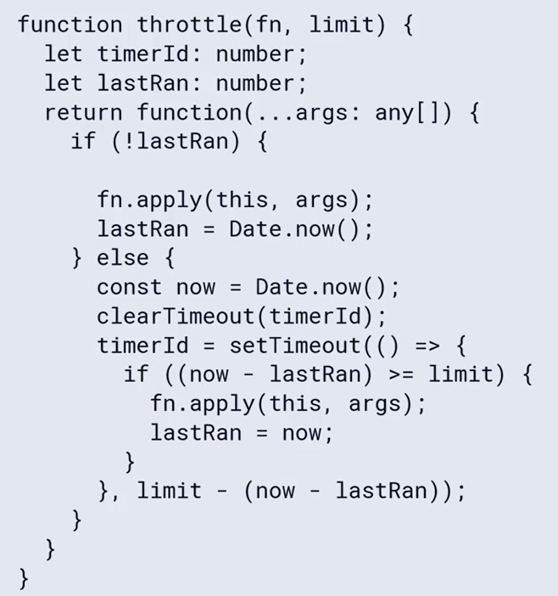

Debouncing – it ensures that a function is only invoked after a specified delay has occurred since the function was last invoked. If the function is called again before the timer has expired, the function is not invoked, and the timer is restarted. It can used in the look-ahead component. Think of debouncing as waiting for a stream of events to have stopped, and then invoking a function.

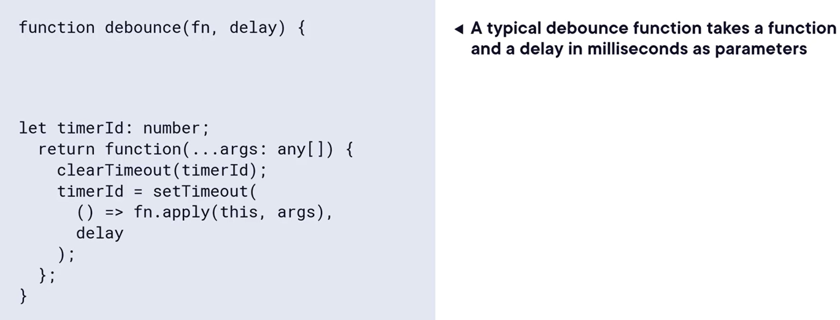

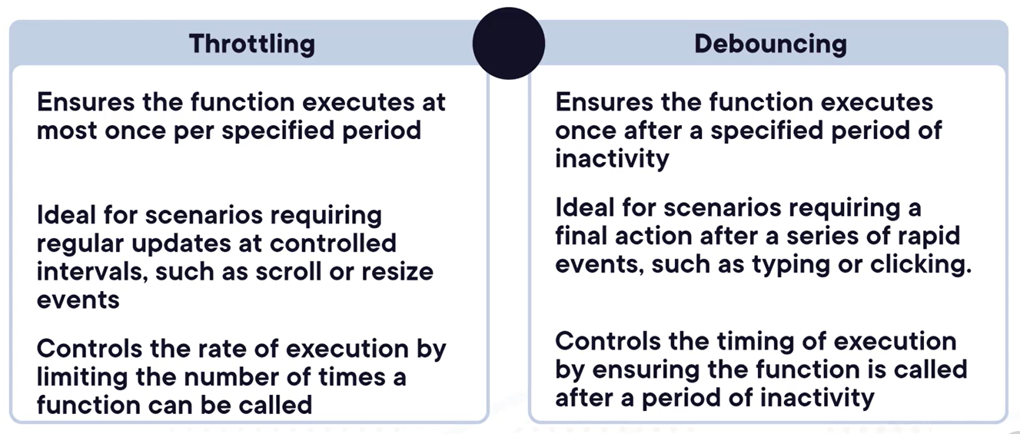

Memorization and Caching –

Memorization is a specific form of caching, store the result of function calls based on inputs. Real world scenario would be calculating Fibonacci numbers. Useful for function with expensive computations that are often called with the same parameters.

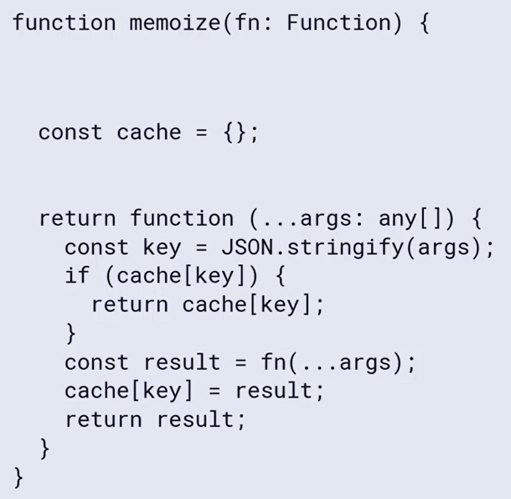

Caching – Caching is more general term referring to storing data temporarily to avoid have to get or calculate that data again. Not limited to function calls – any data or resources that is expensive to get or compute. Real world example would be caching of static assets in the browser – images, etc, are stored in the browser’s cache by domain.

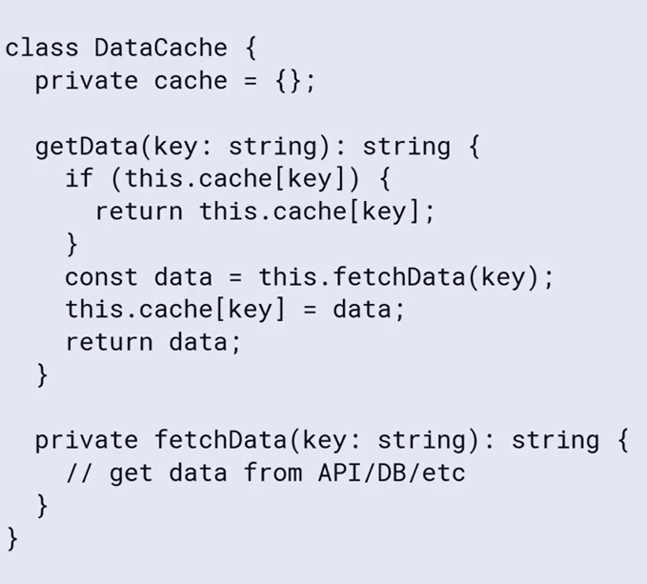

Both memorization and cache can improve performance by avoiding redundant data retrieval or computations.

Testing best practices – writable readable tests (group related tests together into suites), unit tests should be completely independent (each one should be completely isolated and should be run into any order).

Use a modern test runner like Jest which comes with mocking and assertion APIs built on top of Jasmine. Use a familiar syntax of describe/it/expect. Much faster than Karma. We should generally air for 80%+ code coverage for unit tests and should avoid chasing the elusive and unreachable 100% code coverage. Use the AAA format for tests. Mock external dependencies, avoid mocking internal dependencies.

# Configuring and Compiling TypeScript 5 Projects

The TypeScript Compiler (TSC) is a tool that underlines almost all processes which turn typescript into javascript.

We can omit the global installation of TypeScript necessary to call tsc from the command line in some OS by using npx. The npx stands for node package execute and it is used to run a package directly from its source code on npm.

With HMR (hot module reload) feature, it can reload the update on the page without refreshing the browser. It can just swap in and out the affected code without needing to start the application from scratch or having UI framework re-render it. Vite build tool provide this feature by default.

File and directory watching configuration – priority polling interval, dynamic priority polling, file system events (FS Events), FS Events on parent directory, FS Events with Dynamic Priority polling and default.

We can also use the environment variables to edit watch settings through TSC_WATCHFILE and TSC_WATCHDIRECTORY. This approach will be better when most efficient watch configuration for one workstation may not be the best for another. If we don’t provide any environment specific watch file then it will be default to .tsconfig file.

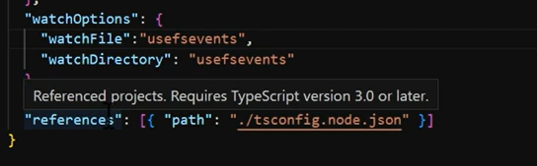

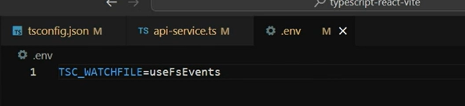

We can use a standard tsconfig settings from a base file, with TS 5+ version we can specify multiple bases. It will reduce the code in our tsconfig.json file (only contains the specific setting if need override).

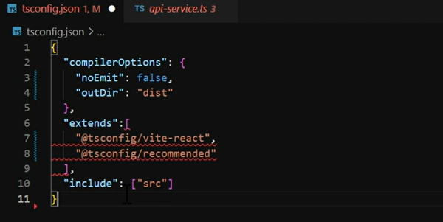

Supporting JavaScript in TypeScript project – allowJS, checkJS, maxNodeModuleDepth –

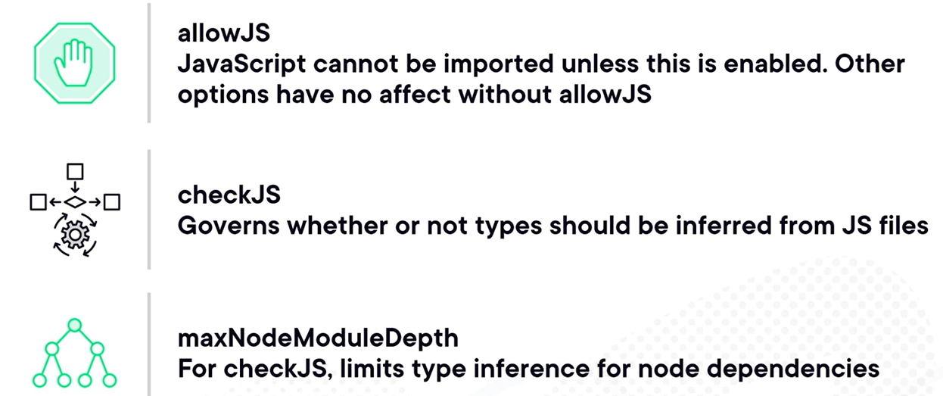

Inferring types from JS files by configuring checkJS - it uses automatic type inference based on default values, but it is less consistent than manually specified types.

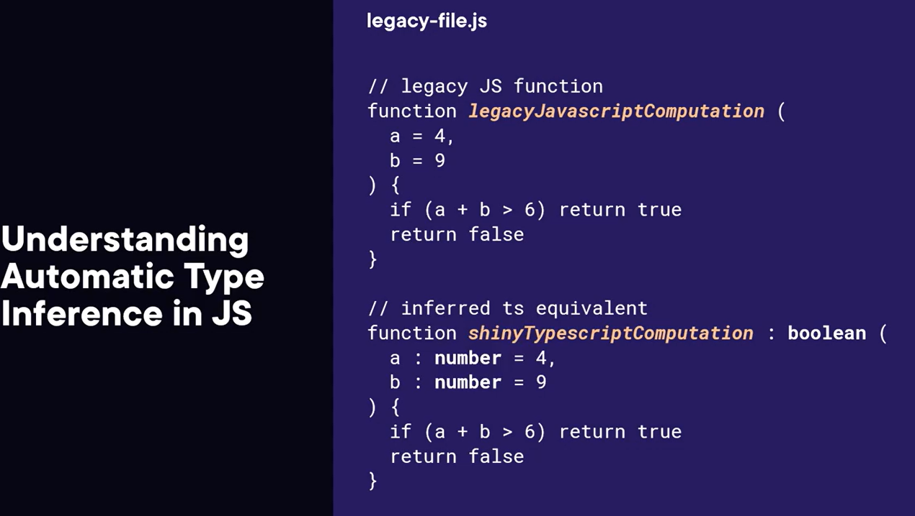

Advantage and disadvantage using JS in your TS project –

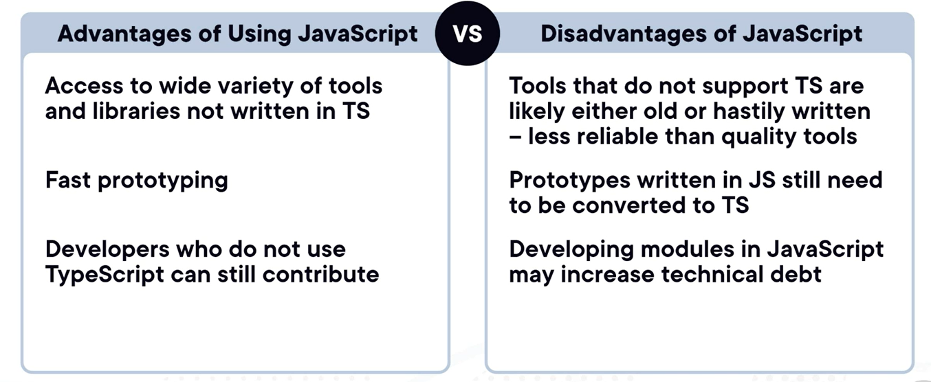

noImplicitOverride setting –

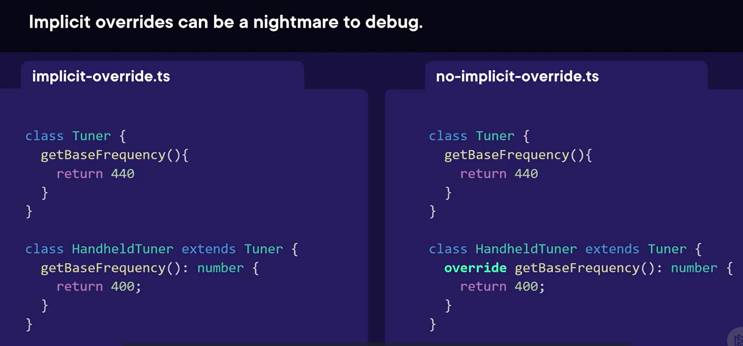

Project references are a feature that allows you to structure your TS programs into smaller pieces. Suppose a module is built by a separate team – your application does not need to know the internals, only needs to implement the public methods. We can use project references to implement this outside code without complicating the main application. These modules which we want to import are called composite applications which are meant to be imported into other apps, have higher quality standard, must specify every included file, must support declarations, must employe stricter error checking.

Instead of simply imported the typescript files, we should use the Project references feature as it offers an incremental build (only affected projects are rebuilt when code changes), all-in-one build (a project and all its dependencies can be built at once), customer-facing (easier to composite projects into APIs or Libraries as they follow strict guidelines for their declaration and source files).

Composite project setting file –

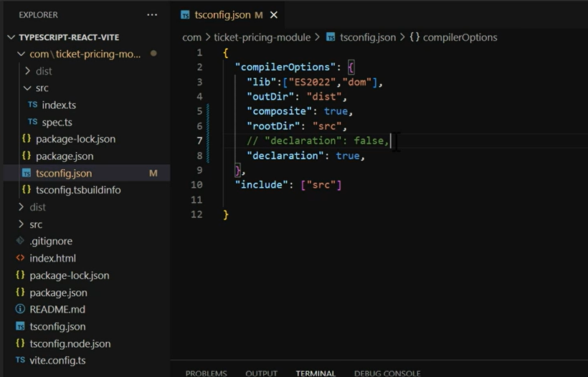

In the consuming application we just need to add the path of the folder which contains the composite project’s tsconfig file. It will use the incremental build feature which will promote faster development cycle because only when specific composite or consuming application gets changed only then it will be re-build otherwise it won’t build it again unnecessarily –

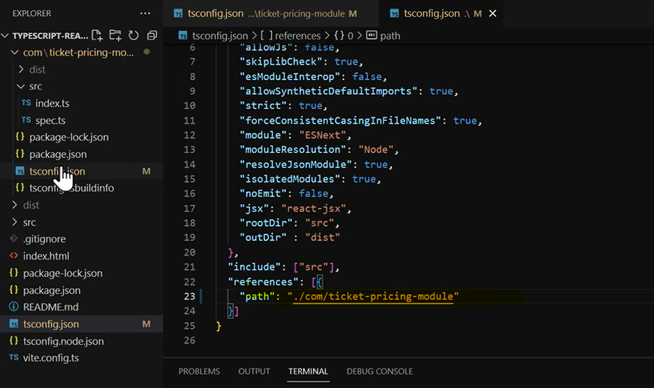

# Consuming Web APIs with TypeScript 5

Improvements in TS 5 – Decorators, const Type parameters, support for Export type, improved Error Messages, smaller size (faster compiled times and smaller file sizes), new http client API, improved type inferences, support for asynchronous iterators, new security features, improved support for modules.

The “never” type provides safety in scenarios where certain values or conditions should never occur, this is a guardrails concept.

For variables with uncertain or unknown types, especially when dealing with dynamic user inputs or APIs that accept diverse values, to handle such scenario, TypeScript introduces the unknown type.

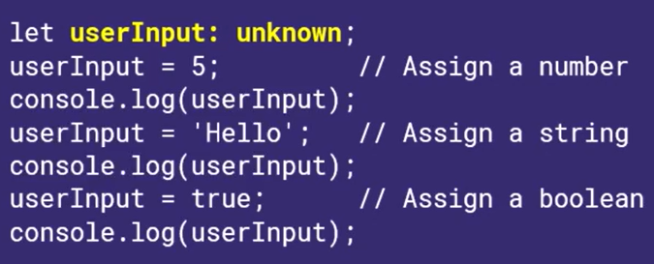

Type assertions – two ways – using angular brackets and by using “as” –

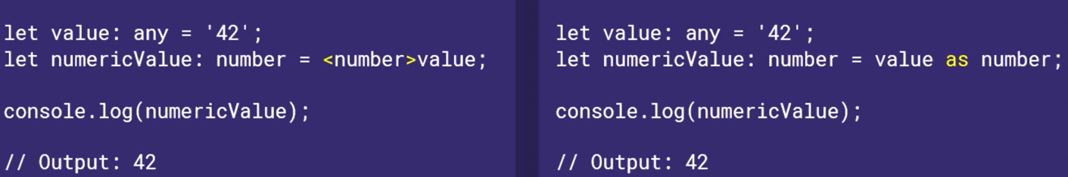

Namespace vs. modules –

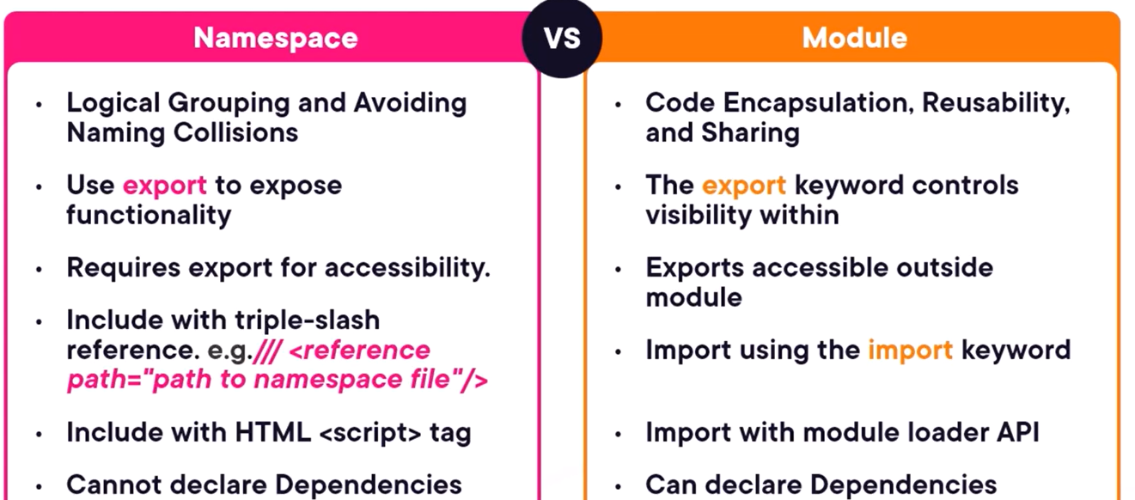

Key features and importance of Fetch API – streaming (in case of large file) and progress tracking, native integration, part of modern web development.

Fetch API alternatives – XMLHttpRequest, Axios, SuperAgent, Got.

HTTP Verbs (Non-Standard) –

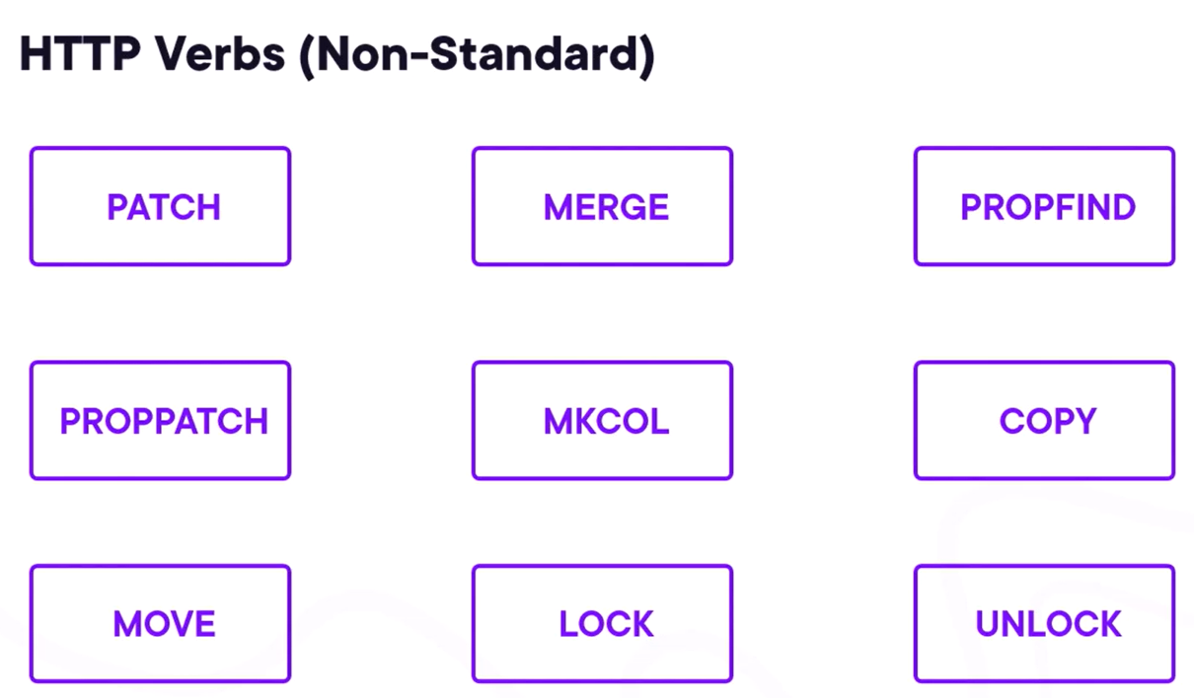

Type casting and type assertions – type casting is the technique of explicitly converting data from one type to another, implying JS style casting functions such as Number, String and so on. Type assertion is similar to type casting, but is achieved using the angular bracket syntax or using the as keyword. Type assertion is more of telling the TS that you know more about the type of a value than TS does.

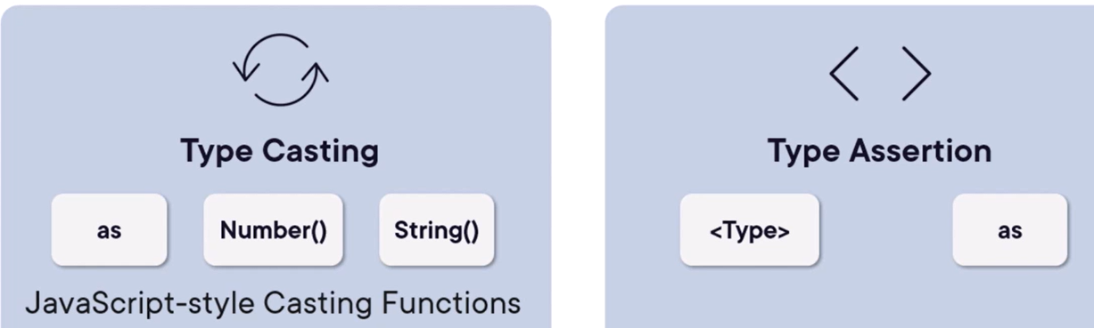

Key reasons to customize headers – authentication, content-type, accept, cache-control, other metadata.

Key reasons to customize request headers – preceisoin in HTTP method selection, fin-tuning with query parameters, crafting data-rich request bodies, efficient time management with timeouts, controlling response formats.

We can use query parameters to refine the data requests.

JSON selectors/query –

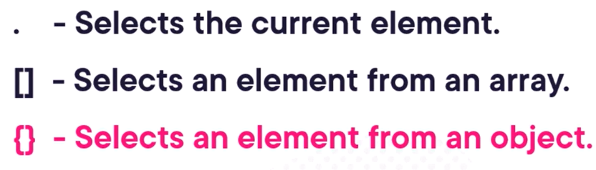

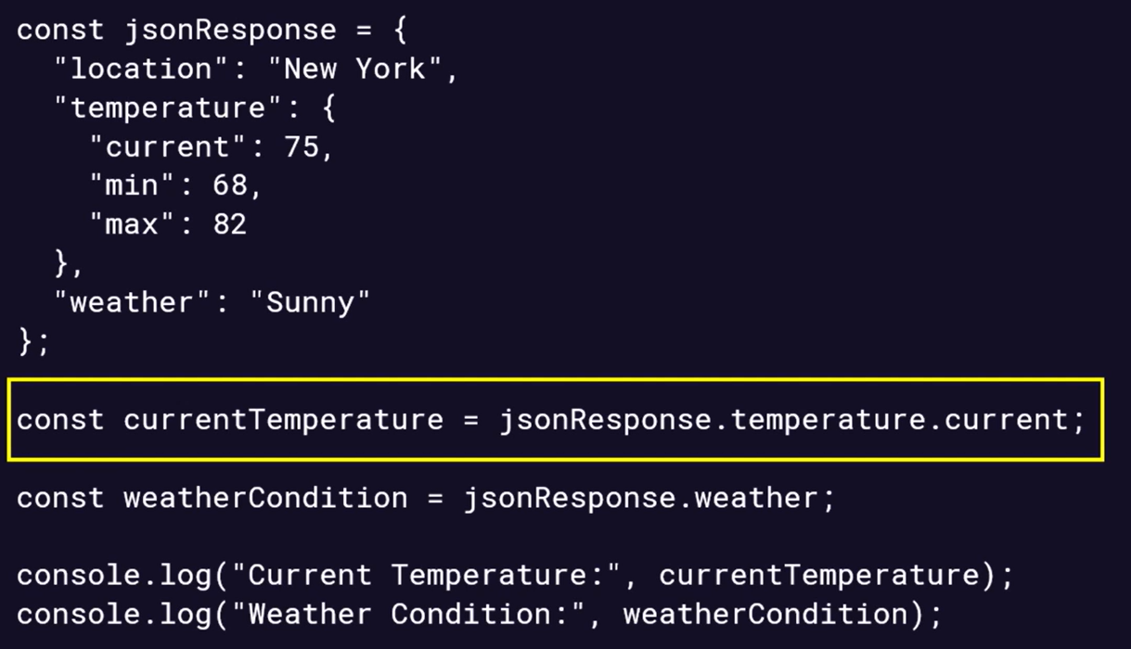

Streaming vs. server-client conversation –

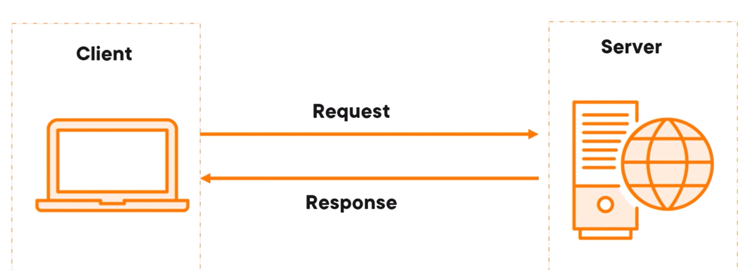

Streaming like sending large data files like video files to improve the user experience -

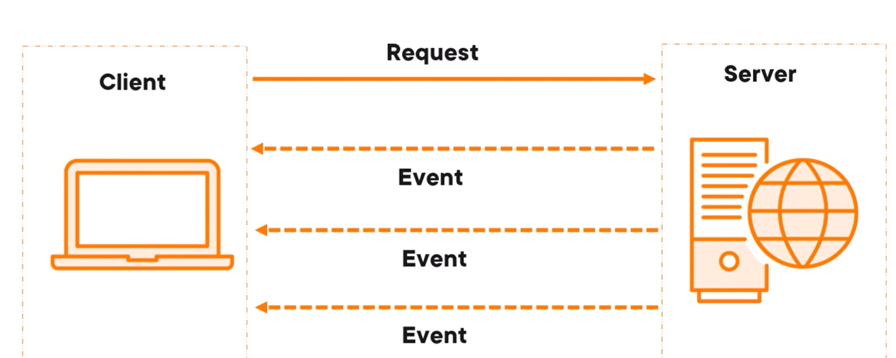

Code Example – we will set variables for total size and chunks and calling each chunk one by one till we get the whole response –

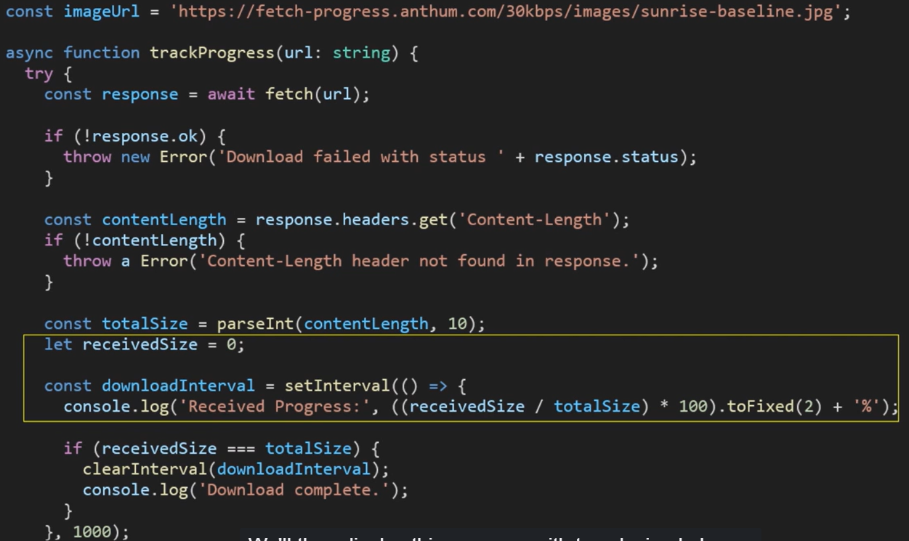

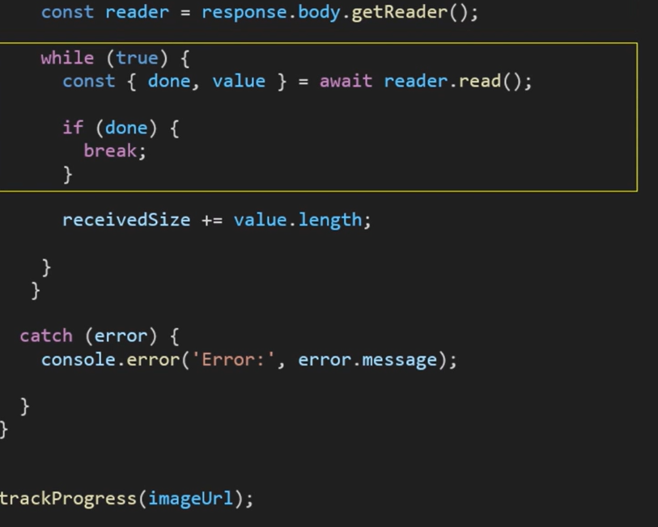

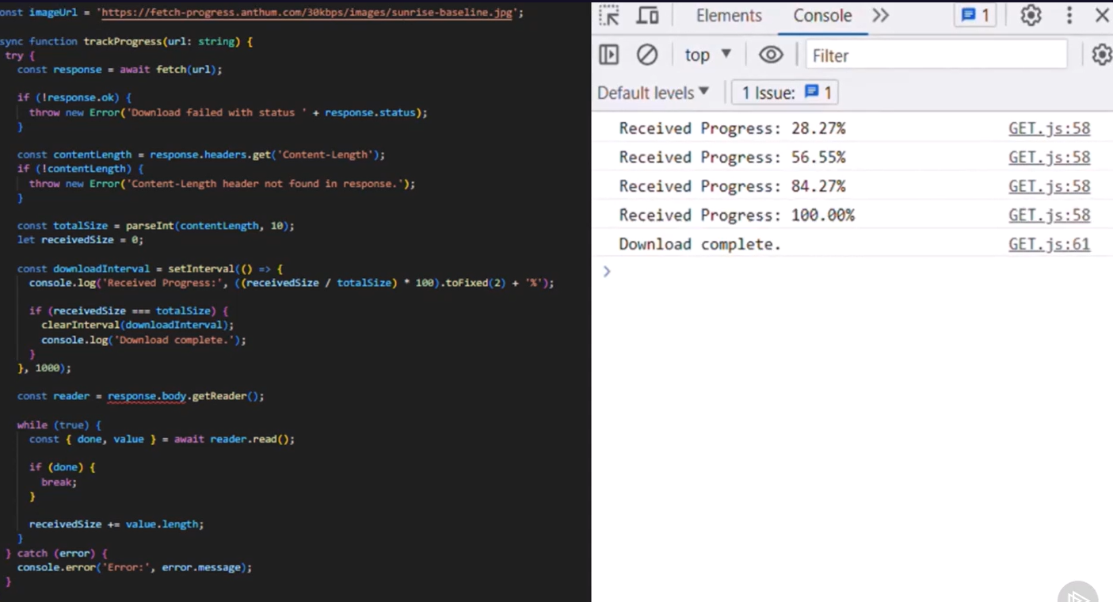

Status codes – 1xx –

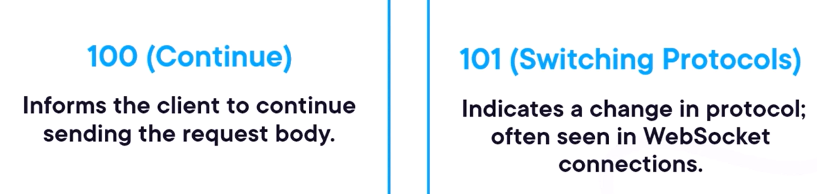

Status codes – 2xx –

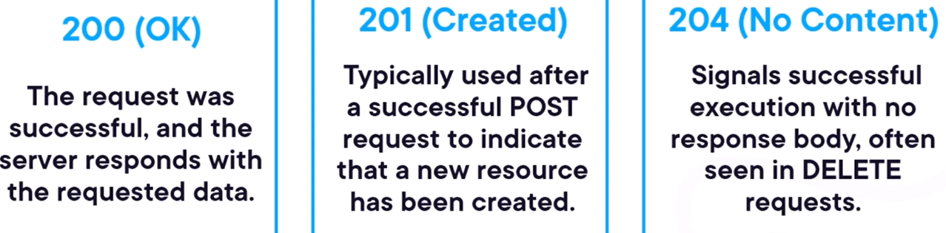

Status codes – 3xx –

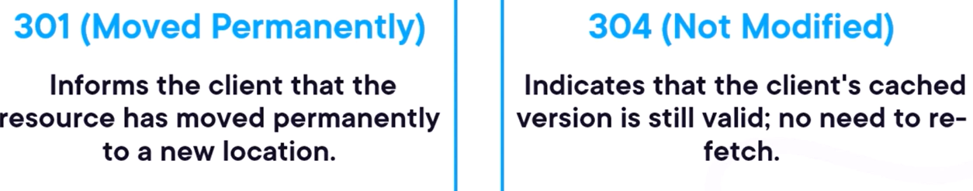

Status codes – 4xx –

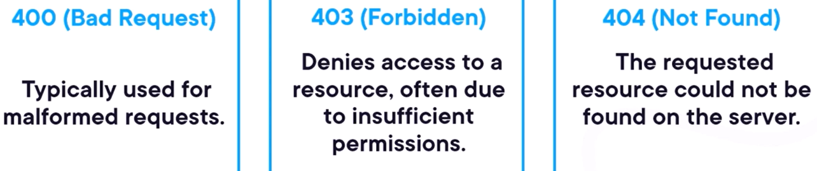

Status codes – 5xx –

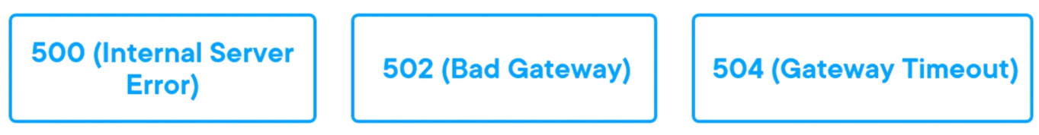

# Problem Solving (LeetCode, HackerRank, CodeWars)

## 1. Arrays

1. Two Sum
2. Remove Duplicates from Sorted Array
3. Move Zeroes
4. Rotate Array
5. Maximum Subarray
6. Contains Duplicate
7. Intersection of Two Arrays
8. Plus One
9. Missing Number
10. Majority Element
11. Best Time to Buy and Sell Stock
12. Valid Mountain Array
13. Find All Numbers Disappeared in an Array
14. Height Checker
15. Squares of a Sorted Array
16. Minimize Maximum Pair Sum in Array
17. Third Maximum Number
18. Relative Sort Array
19. Check If N and Its Double Exist
20. Valid Sudoku
21. **Find Pivot Index**
    1. Find the index where the sum of elements on the left equals the sum on the right.
22. **Largest Number at Least Twice of Others**
    1. Find if the largest number in an array is at least twice as large as the others.
23. **Replace Elements with Greatest Element on Right Side**
    1. Replace every element with the greatest element among the elements to its right.
24. **Find the Distance Value Between Two Arrays**
    1. Calculate the distance value between two arrays based on given conditions.
25. **Array Partition I**
    1. Partition an array to maximize the sum of min-pairs.
26. **Maximum Average Subarray I**
    1. Find the subarray with the maximum average.
27. **Binary Search in a Rotated Array**
    1. Search for an element in a rotated sorted array.
28. **Split Array into Consecutive Subsequences**
    1. Check if the array can be split into consecutive subsequences.
29. **Can Place Flowers**
    1. Check if flowers can be placed in a flowerbed without violating the rule.
30. **Max Consecutive Ones**
    1. Find the maximum number of consecutive 1s in a binary array.
31. **Array Nesting**
    1. Find the length of the longest set created by a nesting operation.
32. **Find Pivot in a Rotated Sorted Array**
    1. Find the index of the smallest element in a rotated sorted array.
33. **Candy Distribution**
    1. Distribute candies to children with specific rules.
34. **Toeplitz Matrix**
    1. Check if a 2D array is a Toeplitz matrix.
35. **Sort Array by Parity**
    1. Rearrange an array so that all even elements come before all odd elements.

## 2. Strings

1. Reverse String
2. Reverse Words in a String III
3. Valid Palindrome
4. First Unique Character in a String
5. Implement strStr()
6. Longest Common Prefix
7. Count and Say
8. Valid Parentheses
9. Is Subsequence
10. Add Binary
11. Check if the Sentence Is Pangram
12. Replace All Digits with Characters
13. Determine if String Halves Are Alike
14. Merge Strings Alternately
15. Robot Return to Origin
16. Defanging an IP Address
17. Truncate Sentence
18. Sort Characters By Frequency
19. Count Binary Substrings
20. Longest Substring Without Repeating Characters
21. **Remove Vowels from a String**
22. **Check for Palindrome**
23. **Longest Palindromic Substring**
24. **Find the Index of the First Occurrence in a String**
    1. Implement a function like strStr() to locate the first occurrence of a substring.
25. **Count Words in a String**
    1. Count the number of words in a string separated by spaces.
26. **Find and Replace Pattern**
    1. Given a list of words, return the ones matching a given pattern.
27. **Reverse Only Letters**
    1. Reverse the letters in a string, keeping non-letter characters in their original positions.
28. **Buddy Strings**
    1. Check if two strings are similar by swapping two letters in one of them.
29. **Rotate String**
    1. Check if one string is a rotation of another.
30. **Longest Common Subsequence**
    1. Find the longest common subsequence between two strings.
31. **String to Integer (atoi)**
    1. Implement string-to-integer conversion.
32. **Reorganize String**
    1. Rearrange a string so that no adjacent characters are the same.
33. **Repeated Substring Pattern**
    1. Check if a string is a repeated substring of itself.
34. **Check if a String Contains All Binary Codes of Length K**
    1. Determine if a string contains all possible binary codes of length K.
35. **Add Strings**
    1. Add two non-negative numbers represented as strings.

## 3. Hashing

1. Contains Duplicate II
2. Valid Anagram
3. Intersection of Two Arrays II
4. First Unique Character in a String
5. Two Sum II (Sorted Array)
6. Find the Difference
7. Single Number
8. Find All Anagrams in a String
9. Group Anagrams
10. Happy Number
11. **Unique Email Addresses**
    1. Count the number of unique email addresses in a list.
12. **Find the Difference**
    1. Find the letter added to a string after shuffling and adding a single extra character.
13. **Single Number**
    1. Find the number that appears exactly once in an array where others appear twice.
14. **Distribute Candies**
    1. Determine the maximum number of candy types a person can eat.
15. **Longest Harmonious Subsequence**
    1. Find the longest subsequence in which the difference between max and min is 1.
16. **Count Good Meals**
    1. Count pairs of dishes whose total sum is a power of two.
17. **Smallest Subarray with All Occurrences of the Most Frequent Element**
    1. Find the shortest subarray containing all occurrences of the most frequent number.
18. **Two Sum II (Sorted Input)**
    1. Return indices of two numbers in a sorted array that sum up to a target.
19. **Group People Given the Group Size They Belong To**
    1. Group people based on the sizes given.
20. **Subdomain Visit Count**
    1. Count the number of visits to each subdomain in a given list.
21. **Jewels and Stones**
    1. Count the number of jewels in a string of stones.
22. **Sum of Unique Elements**
    1. Sum all unique elements in an array.
23. **Check If Two Arrays Are Equal by Reversing Subarrays**
    1. Determine if two arrays can be made equal using subarray reversals.
24. **Ransom Note**
    1. Determine if a ransom note can be created using letters from a magazine.
25. **Max Number of Balloons**
    1. Count how many times the word "balloon" can be formed from a given string.

## 4. Math

1. Fizz Buzz
2. Add Digits
3. Power of Two
4. Sqrt(x)
5. Guess Number Higher or Lower
6. Missing Number
7. Roman to Integer
8. Excel Sheet Column Number
9. Factorial Trailing Zeroes
10. Check If It Is a Straight Line

## 5. Linked Lists

1. Reverse Linked List
2. Merge Two Sorted Lists
3. Remove Duplicates from Sorted List
4. Delete Node in a Linked List
5. Intersection of Two Linked Lists
6. Linked List Cycle
7. Palindrome Linked List
8. Remove Linked List Elements
9. Odd Even Linked List
10. Middle of the Linked List

## 6. Trees

1. Maximum Depth of Binary Tree
2. Symmetric Tree
3. Binary Tree Inorder Traversal
4. Binary Tree Preorder Traversal
5. Path Sum
6. Diameter of Binary Tree
7. Invert Binary Tree
8. Minimum Depth of Binary Tree
9. Convert Sorted Array to Binary Search Tree
10. Same Tree

## 7. Recursion

1. Pascal's Triangle
2. Fibonacci Number
3. Power of Three
4. Climbing Stairs
5. Reverse String (Recursively)
6. Sum of Digits of a Number
7. Generate Parentheses (Intermediate)
8. Merge Two Binary Trees
9. Factorial
10. Search in a Binary Search Tree

## 8. Searching & Sorting

1. Binary Search
2. Find First and Last Position of Element in Sorted Array
3. Search Insert Position
4. Guess Number Higher or Lower
5. Merge Sorted Array
6. Sort Colors
7. Intersection of Two Arrays
8. Kth Largest Element in a Stream
9. Squares of a Sorted Array
10. Relative Ranks

# Debug and Optimize Asynchronous JavaScript

Event loop – JS does one thing at a time, operating on one thread and with one call stack, which performs synchronous tasks. Some of these tasks are functions. Functions are given their own execution context, which includes its own stack. A function can create and perform its own tasks. When all function tasks are complete the execution context is closed and the call stack is free to take on the next task. A function can call another function and then another function so on, right up to stack overflow.

Good example of event loop in JS - <https://app.pluralsight.com/ilx/video-courses/f369ef57-d6d6-4683-bbb2-82376eb1e730/0aa46754-8f64-4646-aa7a-96e22f6c8e19/d3c168c9-ede4-44f7-b0d5-7ccc0c7a516a>

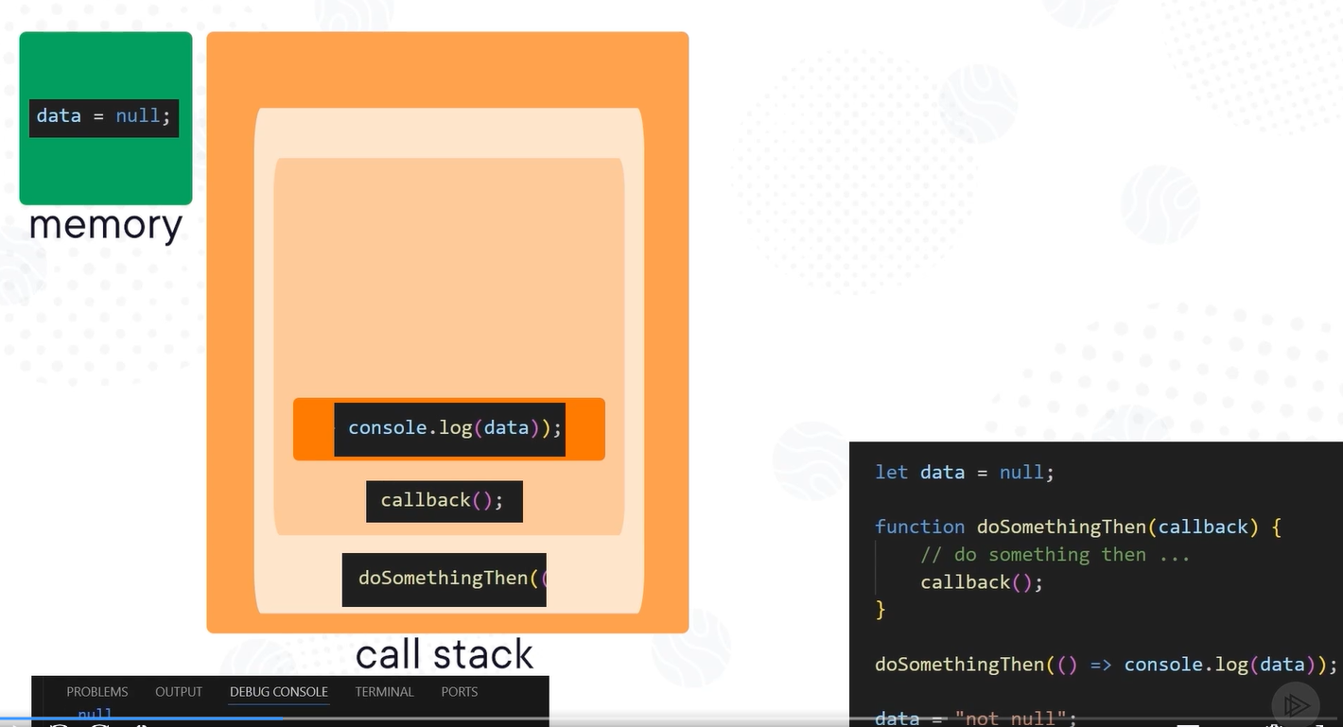

With setTimeout() – JS is a general purpose language, but for apps to do things, they need a bit of help in form of APIs, in the browser, they are web APIs, in Node they are modules. They are probably not written in JS and not constrained to a single thread, like a timer manager that has access to the system clock and one of its interfaces setTimeout().

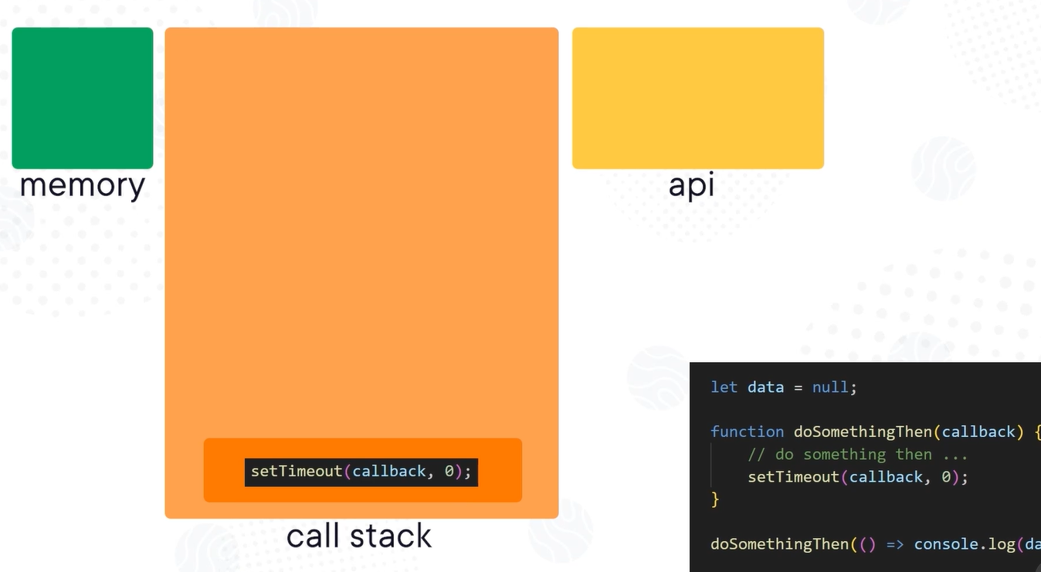

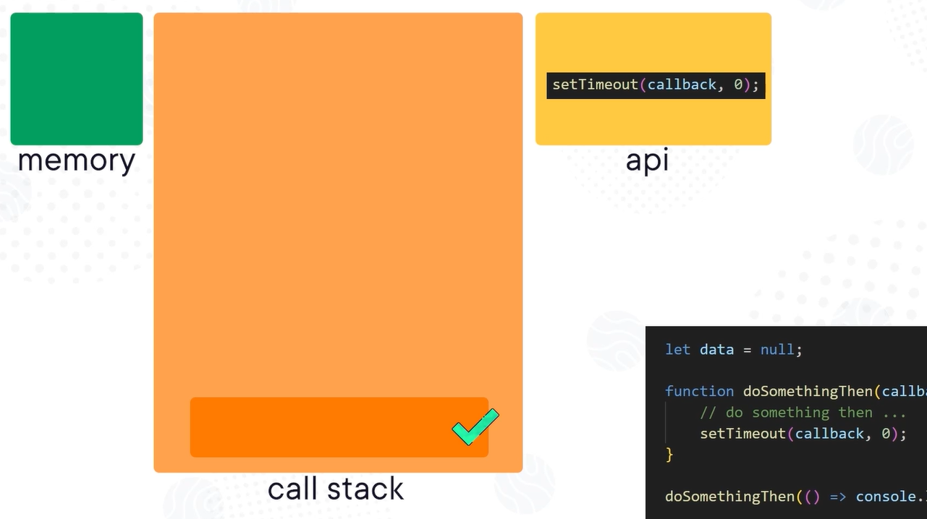

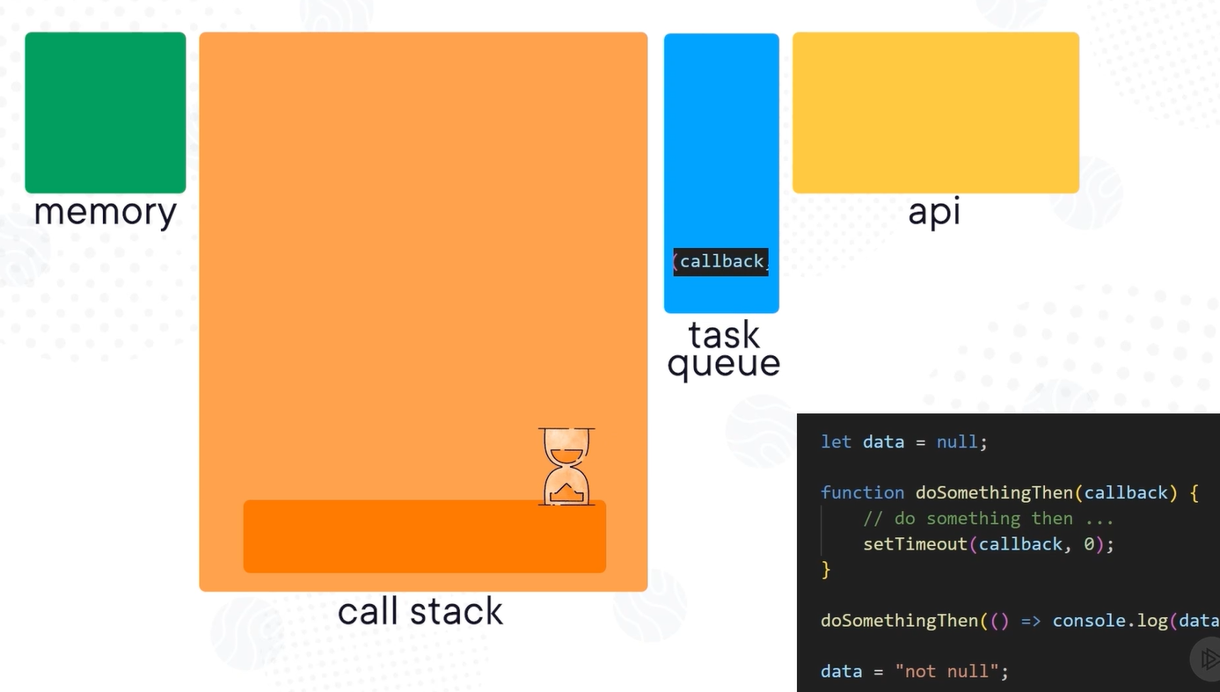

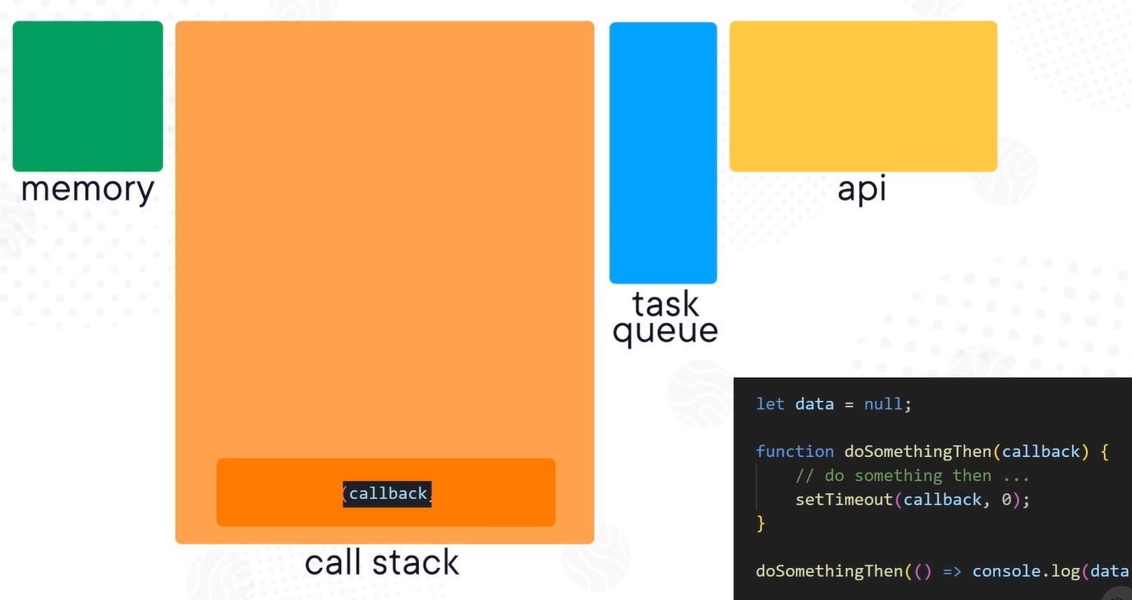

With promise - they are a bit different than setTimeout, they get held in memory until they settle resolve, or reject, at which time the callback is inserted into a different queue called micro-task queue, these tasks are higher priority. So the call stack is available, even if there are items in the task queue the micro task queue is emptied first, then the tasks from task queue and then in the last the next synchronous tasks form the code.

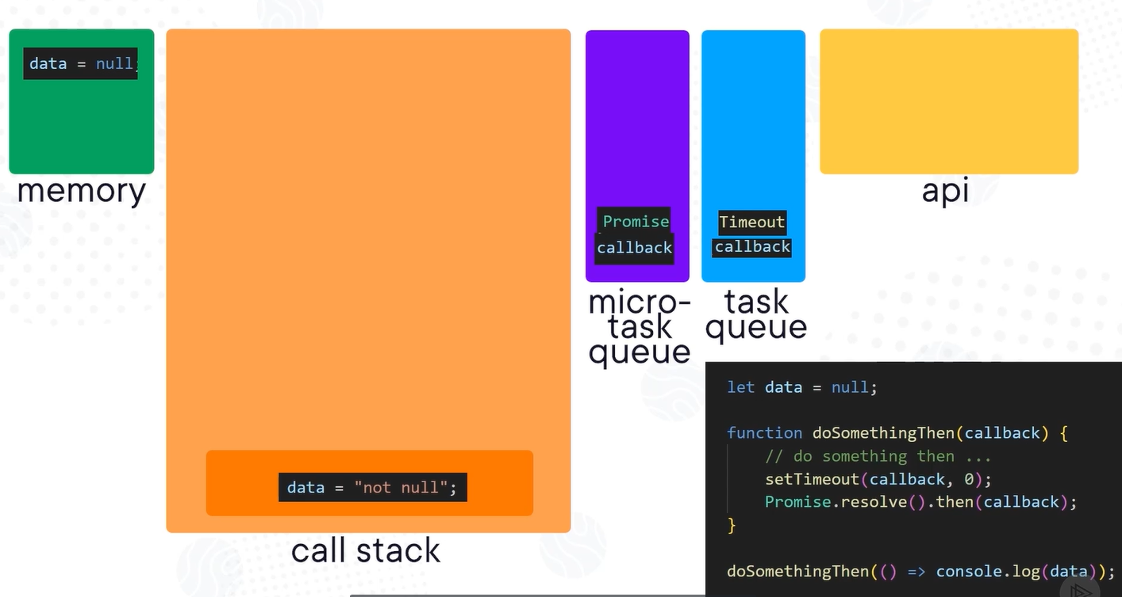

Examples of tasks and microtasks –

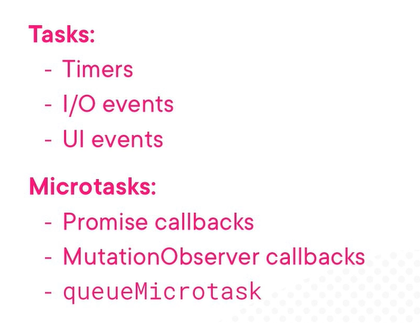

The setImmediate() in node.js is faster than setTimout() as it directly sends the callback to the task queue instead in the API first. The process.nextTick() push the things into the micro-task queue.

The “await” keyword forces async tasks within the same function into synchronous behavior.

Good question to ask in interview –

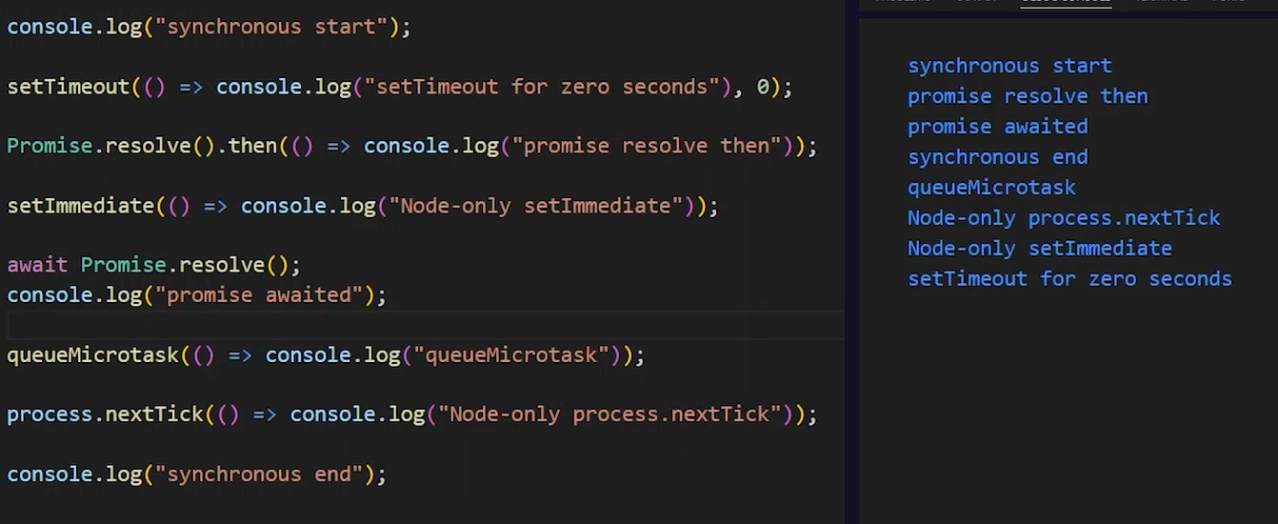

Interview question related to promise –

<https://app.pluralsight.com/ilx/video-courses/f369ef57-d6d6-4683-bbb2-82376eb1e730/0aa46754-8f64-4646-aa7a-96e22f6c8e19/d5285976-a2cf-41fd-806e-2df1cb655a72>

<https://app.pluralsight.com/ilx/video-courses/f369ef57-d6d6-4683-bbb2-82376eb1e730/0aa46754-8f64-4646-aa7a-96e22f6c8e19/3d1d5d29-a751-4ee0-9895-702b61c1f73e>

Better predictability with timing is one reason “async await” tends to be the preferred syntax over promise chaining.

The async keyword automatically wraps the function return value into a Promise also not need to resolve anything. So below code can be rewritten using async keyword which makes it more readable –

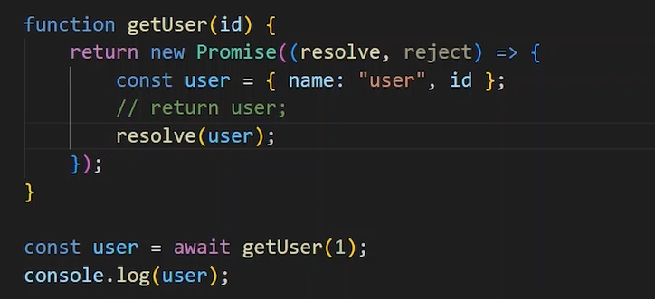

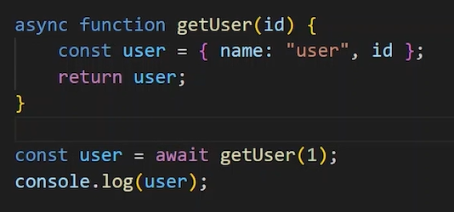

In the chrome dev tools, we can use breakpoints automatically on uncaught exception or caught exception –

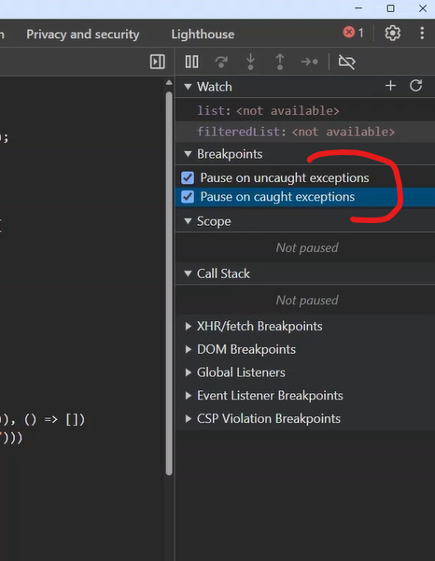

Too many concurrent tasks can overload the event loop or rate limiters on API managers, databases, servers, so it is not always the right solution.

Use below code to make three calls concurrently and return the response in defined sequence not the network response sequence –

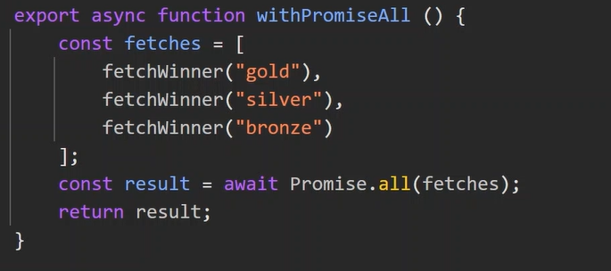

Use of requestAnimationFrame() and requestIdleCallback() method –

<https://app.pluralsight.com/ilx/video-courses/f369ef57-d6d6-4683-bbb2-82376eb1e730/a546a14e-76f5-4071-baf4-58ba72cc5504/237f005e-90f1-4f81-a143-4ebb1540d4a8>

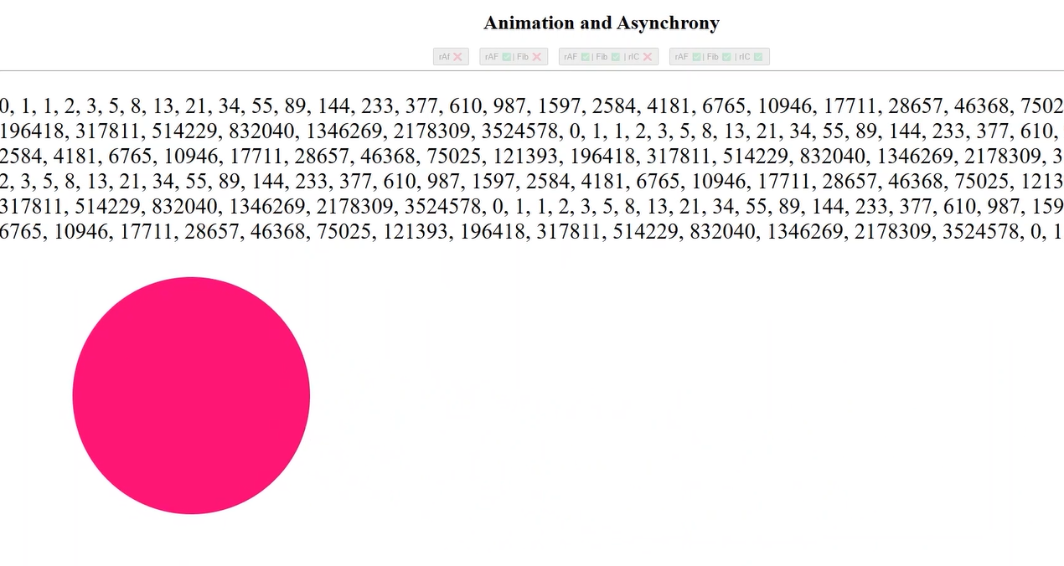

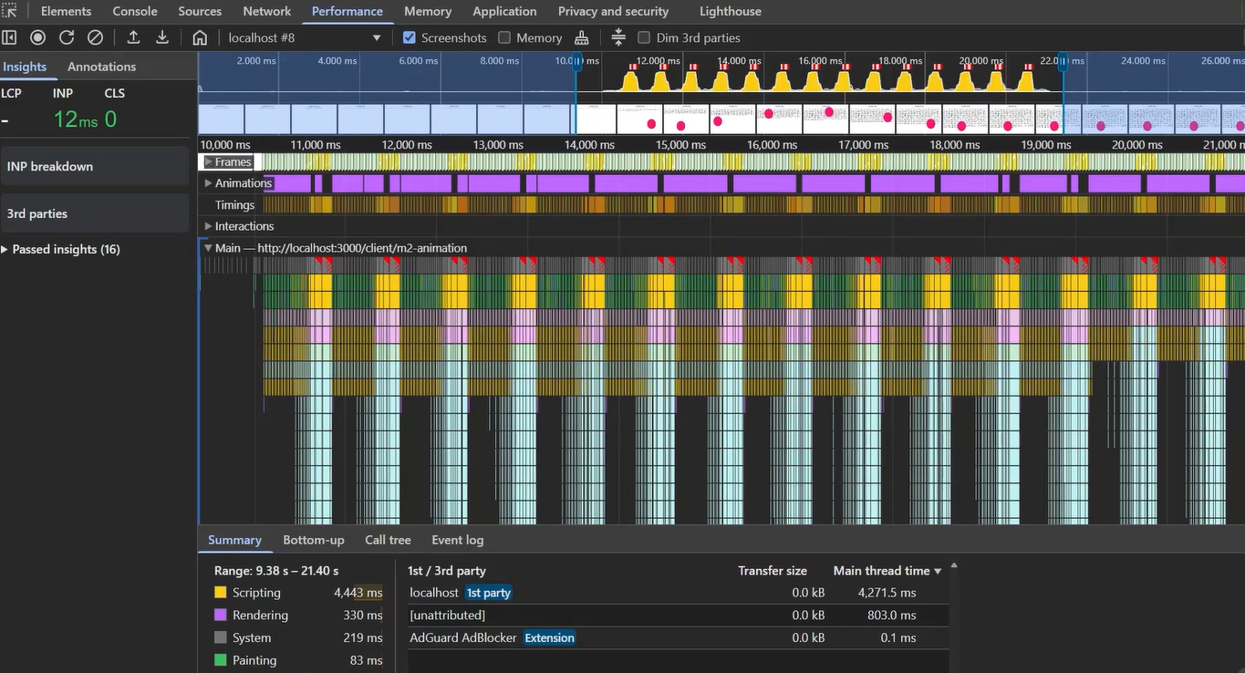

Best practice - While doing the error handling, we can use a approach where we will throw an error with data and error properties as a standard API –

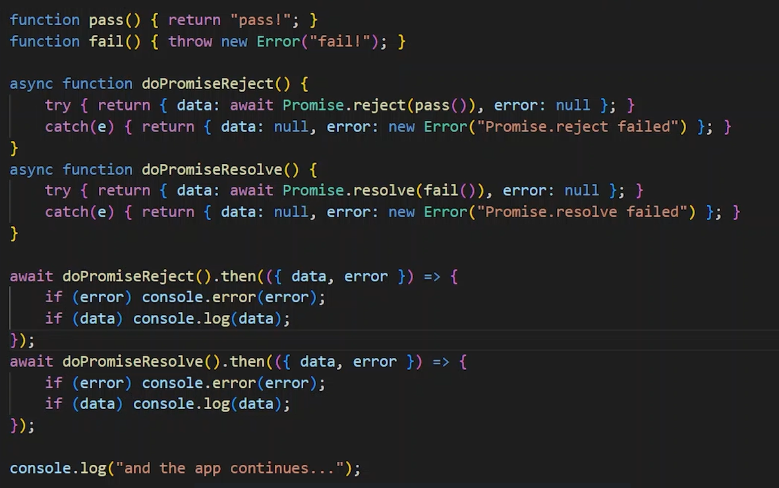

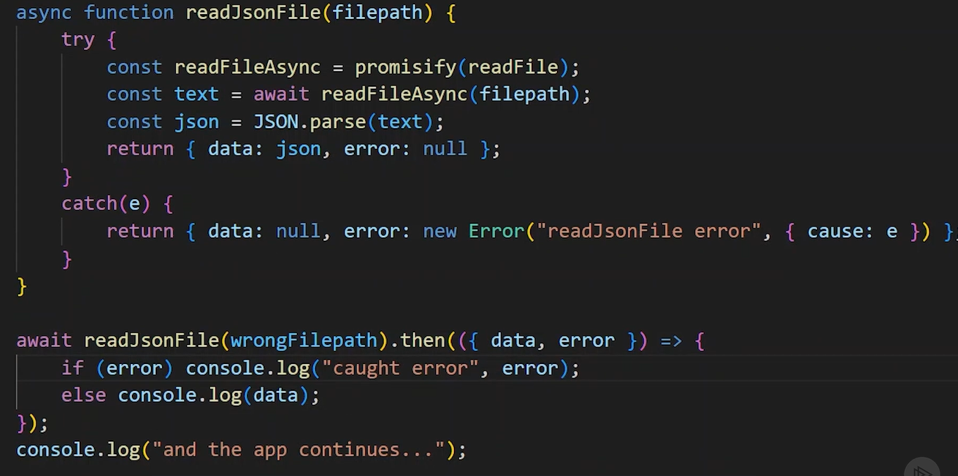

Cancel and retry promises – we can use AbortController() to abort the fetch request in progress because even if we use promise.race() for the remaining service calls, it will still hit the server and return the response. But this functionality also need to be implemented on server like making a “sale” call for a item so that both will be in sync -

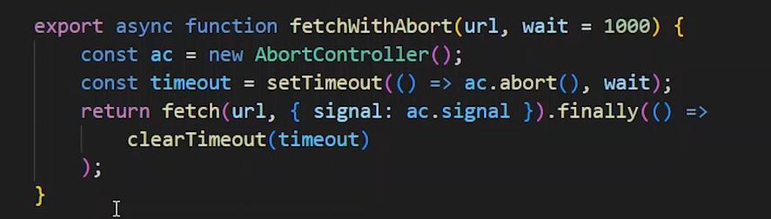

Like for a password checker strength to reduce the network calls, we can use throttling, caching, promise coalescing -

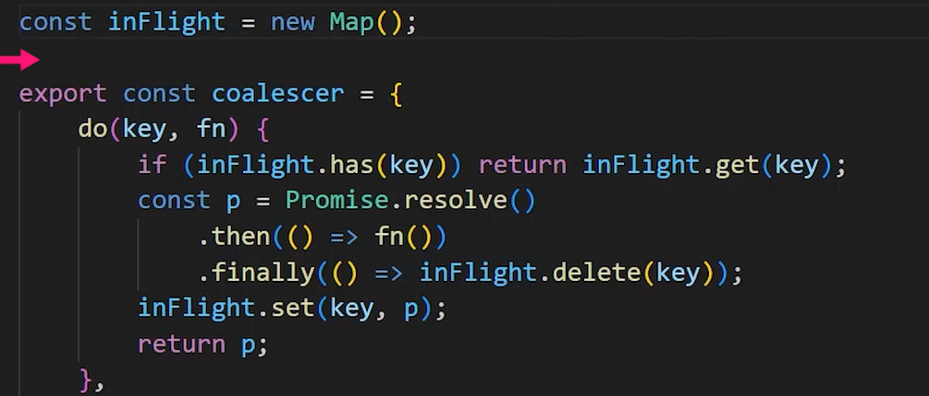

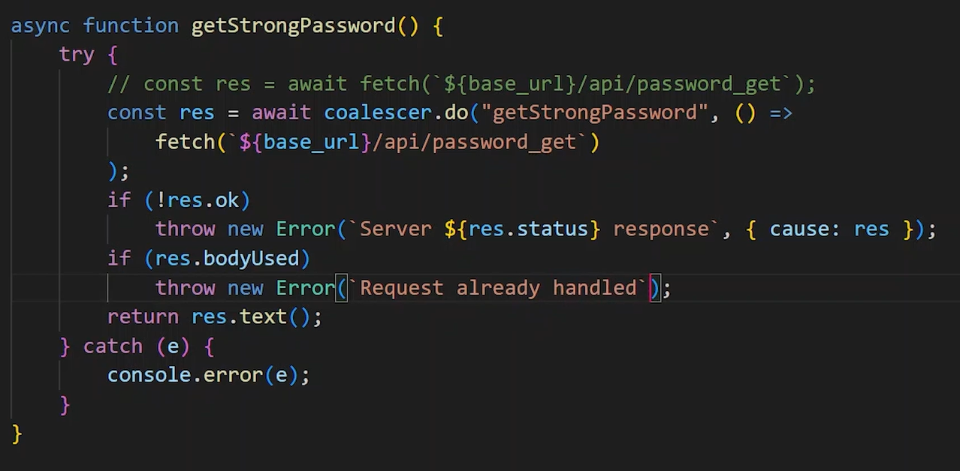

Example of making all requests concurrent or serial using async keyword –

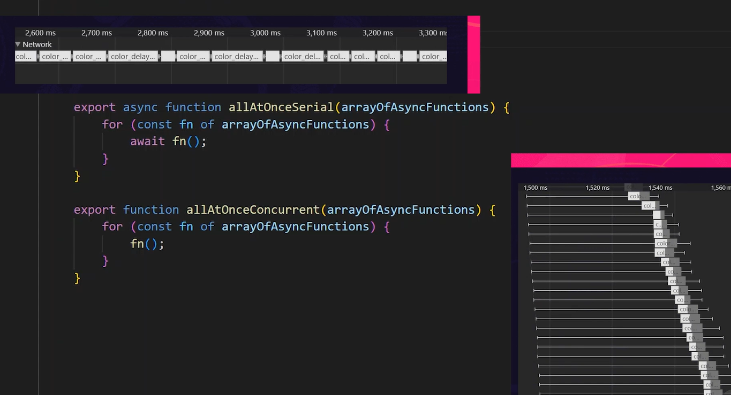

By using batching and concurrency limiting we can manage many task without overloading the system or network to avoid “to many requests” error. We can use Semaphore pattern for it –

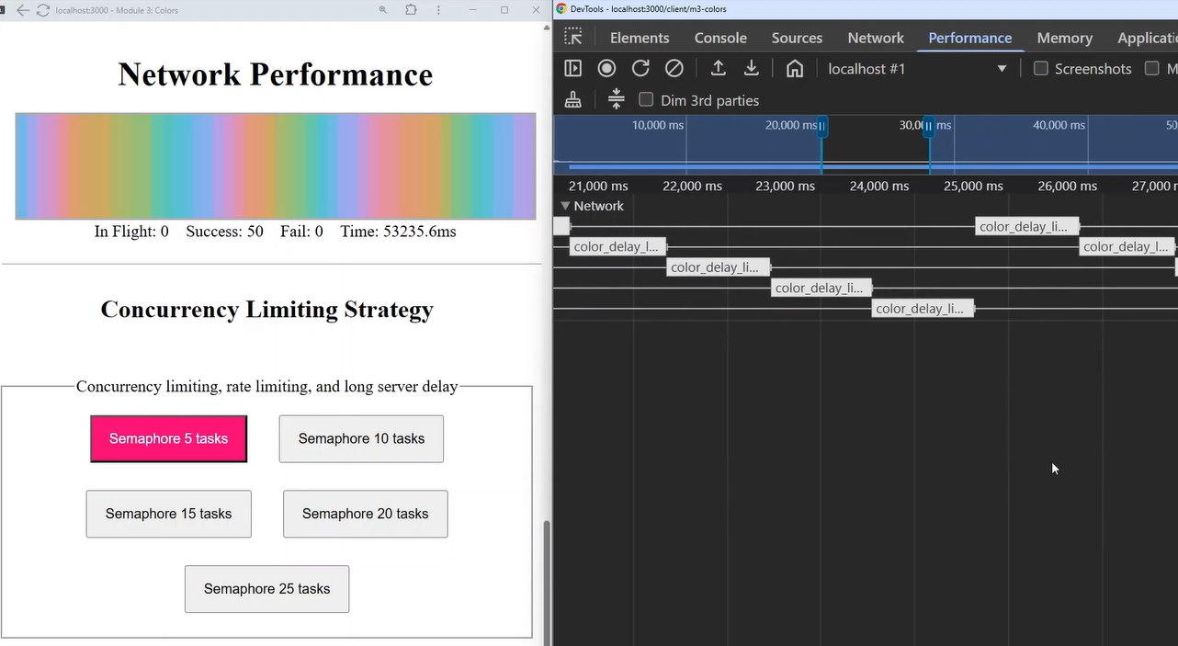

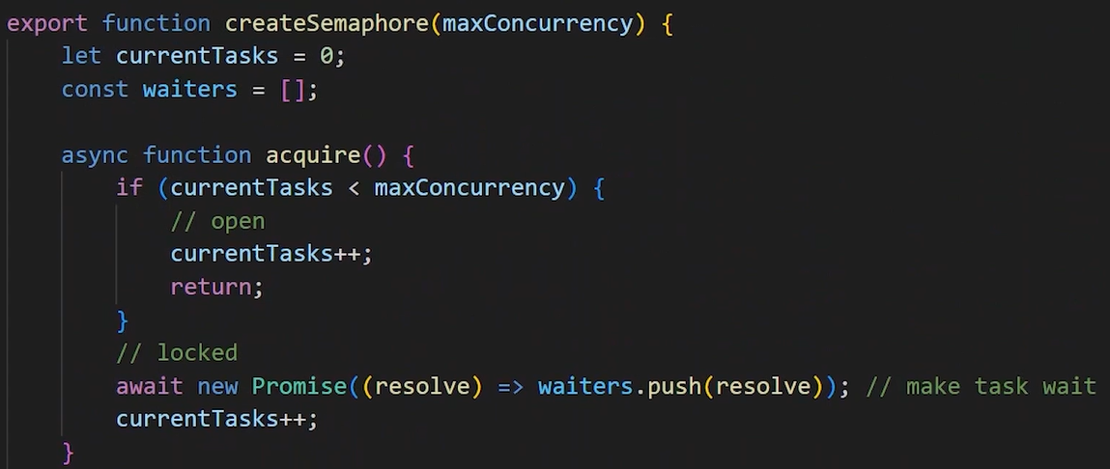

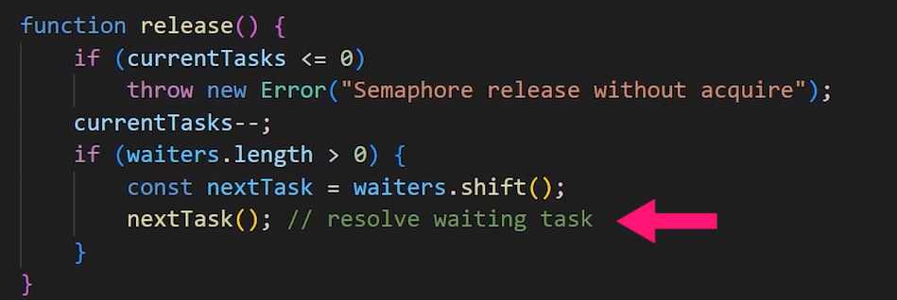

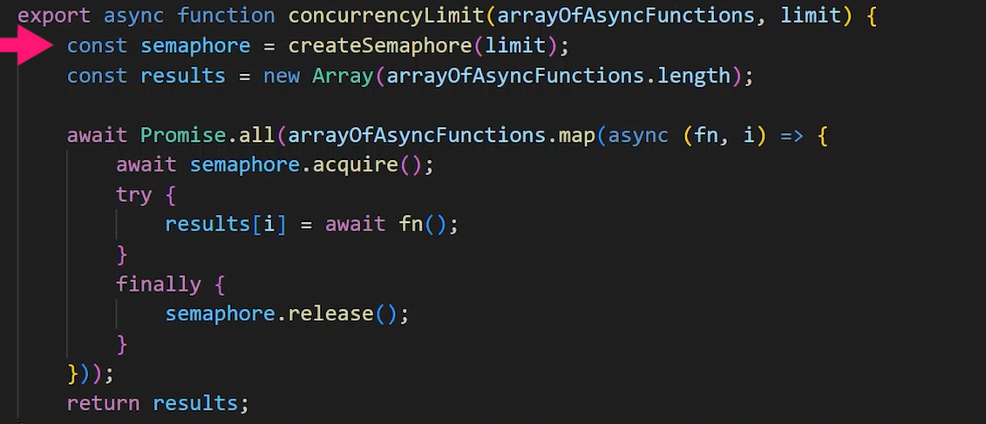

By using web worker we can give major work like Fibonacci calculate to it without blocking the main thread much, it provides a separate worker thread to do the major processing for that task and return only the result to the main thread –

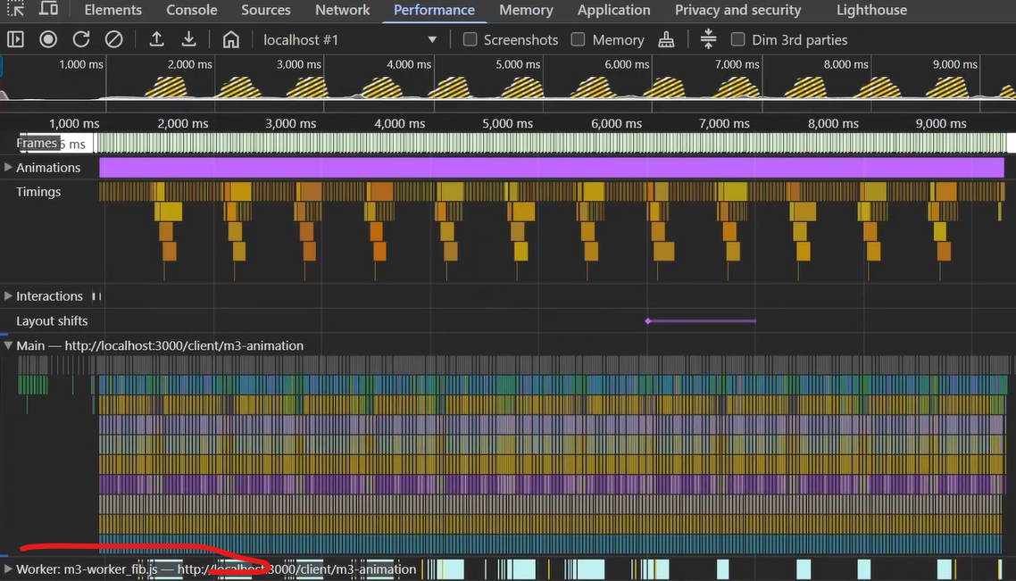

For interview questions – out of choices, more than one can be answer based on the scenario –



